**A Scenario-based Projection of the Number of Girls Expected to be Cut Between 2015 and 2030**

**Kathrin Weny[1]¥, Romesh Silva[2]¥, Berhanu Legesse[3]ϒ, Rachel Snow[4]¥, Nafissatou Diop[5]ϒ**

**Technical Division**

**United Nations Population Fund[6]**

**Last Updated: 2 April, 2018**

**Abstract**

Female genital mutilation (FGM) is a harmful practice that violates the basic rights of women and girls and brings about notable short- and long-term health risks. UN member states have affirmed FGM as a harmful practice and committed to undertake steps to eliminate the practice by 2030 within the framework of the 2030 Sustainable Development Agenda. To date, estimates on the magnitude of girls and women affected by FGM have been subject to a number of data limitations. The new estimates presented in this technical paper are based on recent, nationally representative survey data in 25 countries. We model the age pattern of cutting applying survival analysis and assess the risk of FGM by age. Combining these results with age-specific population estimates and projections provided by the United Nations Population Division, we obtain more precise estimates of the population likely to be affected by FGM between 2015 and 2030, if current practices were to continue. Better data and more refined evidence on FGM are a critical tool to advance effective programming and policy and to protect the rights of women and girls at risk.

**Introduction**

Female genital mutilation (FGM) refers toall procedures involving partial or total removal of the external female genitalia or other injury to the female genital organs for non-medical reasons. The practice of FGM varies in form, ranging from a nick to the female genital area to draw blood, to cutting off of a small amount of flesh, to removing major part of the labia, to sewing the vaginal opening shut, to other manipulation of the female genitalia with a sharp instrument. FGM can cause short- and long-term health complications, including chronic pain, infections, increased risk of HIV transmission, anxiety and depression, birth complications, infertility and, in the worst cases, death (WHO 2008).

The United Nations campaign to end FGM began in 2008, when UNICEF and UNFPA established the joint programme on FGM (UNFPA 2018b), the largest global programme to accelerate abandonment of FGM and to provide support to women and girls who have experienced this harmful practice (UNFPA 2018a). In 2012, the United Nations General Assembly unanimously adopted a resolution condemning the practice of FGM, and called for increased efforts to eliminate the practice (United Nations 2013). This was reaffirmed in December 2014 (United Nations 2015). Finally, in 2015, Female Genital Mutilation was, next to child marriage, mentioned specifically as one of two harmful practices in the Sustainable Development Goal 5.3 in which Member States of the United Nations urged for the complete elimination of both practices by 2030 (United Nations 2017).

The elimination of FGM requires effective policy intervention and programming, which need to be guided by reliable estimates of the expected number of girls to be cut in a given year and how the population of girls at risk evolves over time. As we mark the 10-year anniversary of the joint programme on FGM, it is timely to review FGM levels and assess the population dynamics associated with the practice in the context of the 2030 Sustainable Development Agenda.

UNICEF has estimated that at least 200 million women worldwide live with FGM today (UNICEF 2016). This number is useful for raising awareness within the international community and to inform the public about the scale of the problem. However, such prevalence estimates are difficult for policy makers and program specialists to use when trying to shape evidence-based actions and plan effectively for the future. They are not able to describe the size and nature of *future* risk that FGM poses to women and girls in years to come, nor are they able to capture the age-risk pattern that girls are subject to in each country. In order to precisely predict how many girls are going to be cut per year and country, incidence estimates have to factor in the age pattern of cutting for girls in different countries. Through this, the change in age structure driven by core demographic factors such as fertility and child survival can be taken into account.

**Objective**

In this paper, we present new estimates of the number of girls that are projected to be cut between 2015, the start of the SDG era, until its conclusion in 2030 for 24 countries where FGM is known to be practiced. We focus on 24 countries where nationally-representative data on level and time of cutting are available. We also present these estimates alongside the most recent information from Indonesia, given its large population size, despite detailed FGM microdata not being accessible. The analysis herein combines the risk of being cut for girls aged 0-14 years by single years of age with single-year, sex-specific national population projections. Therefore, this estimate, while holding current levels of FGM constant, allows for detailed insights into the demographic dynamics of the practice and the scale of the problem faced by national government and the global community.

There are two key aspects that make this new approach more precise than previous estimates. First, it makes it possible to match the single-year age at cutting with the single-year age cohorts and does not apply a coarse prevalence or incidence rate across multiple cohorts with notably different FGM experiences. This more granular approach also provides a basis for estimating the expected number of girls to be cut per year. Second, it incorporates newly available data on the FGM status of girls aged 0-14, as reported by their mothers in nationally-representative surveys. These new survey data provide a basis for estimating and projecting the magnitude of females who have experienced or are expected to experience FGM, without the implicit assumption that FGM patterns for older women are representative of those aged 0-14 year olds. In addition, by using the data from more recent born cohorts, namely girls age 0-14 instead of women aged 15-19, we hope to reduce the time lag between the occurrence of the event and its recording through the household survey.

**Data**

To construct projections of the expected number of girls and women to be cut between 2015 and 2030, we use the most recent nationally representative survey data that document the FGM experience of women and girls and the revised national population projections published by the United Nations. [7] For all countries, except Indonesia, survey microdata from the most recent Demographic and Health Survey (DHS) or UNICEF Multiple Indicator Cluster Survey (MICS) are used. In the case of Indonesia, the only nationally-representative survey data on FGM from the Riset Kesehatan Dasar health survey (RISKESDAS) project served as basis for our analysis.[8] In the case of Somalia, two separate surveys were available, one for the Somaliland region and one for Somalia North Eastern Zone. Due to the cultural similarity of the two populations and their geographic proximity, the average of the two data sources was used to construct a national estimate for Somalia.

In the DHS[9] and MICS[10] surveys used in this analysis, data are solely collected from women age 15-49 years old at the time of the survey. These women usually report about whether they have heard of FGM, whether they themselves have experienced FGM, at what age they were cut, who performed the procedure, and if FGM should be continued. Since 2010, DHS and MICS routinely include an additional module and ask all women selected for the FGM module whether all their living daughters are cut and the respective age at cutting (Shell-Duncan 2016).

When quantifying the female population at risk of being cut between 2015 and 2030 in the 24 countries for which survey microdata on FGM are available, we used the latest population estimates and projections published as part of the World Population Prospects (WPP) by the United Nations.[11] Specifically, we used sex-specific, single-year age population projections for each national population for the years 2015 to 2030. These projections are a dynamic representation of the expected population size of female 1-year age cohorts, and thus take into consideration population growth (due to fertility and immigration) and population loss (due to mortality and emigration). These data are updated on a biannual basis to make use of newly released national data and to revise estimates of past trends in fertility, mortality or international migration and to update population age distributions on the basis of newly available census data. We use the WPP projections, as they represent a coherent set of population estimates and projections for all UN member states. The national projections are based primarily on cohort-component projections, from the best available data whereby data inconsistencies with past trends have been addressed prior to the construction of projections.

**Methods**

We estimate the probability of girls aged 0-14 years of experiencing FGM during each year of life, that is the risk of cutting at age 0-years, at age 1-year, at age 2-years, etc. between 2015 and 2030 via application of the Kaplan Meier (Kaplan and Meier 1958) estimator implemented through the Horvitz-Thompson technique (Horvitz and Thompson 1952) using the survival package of Thomas Lumley (Lumley 2018) in R.

This approach was chosen as data for girls younger than 15 are considered to be censored, that is the FGM status we observe at the time of the survey cannot be assumed to be their final one as they might be cut at a later age. Therefore, we are dealing with right-censored data, that is, we know that the girls have not been cut until their current age, which gives us some insight, but we do not know if they are cut in future, which limits our knowledge. While any direct prevalence or incidence estimation will be misleading, the Kaplan-Meier technique, implemented by the Horvitz-Thompson approach accounting for the survey design, allows us to keep these girls in our data set until they are censored, and assumes that they have the same probability of being cut from this point forward as all other girls who are not censored at the time of the survey. Therefore, it is a designated technique to deal with the type of data at hand.

**Framework**

In the context of survival analysis, we observe either the time Ti at which an individual i experiences the event, FGM in our case, or the time Ci at which she is censored. For the analysis the minimum between Ti and Ci is of interest and is called ‘survival time’. As a consequence, survival time is either the girl’s age (if she is uncut, i.e. does not experience FGM and is censored) or the girl’s age at cutting (if she experiences FGM) and only girls younger than 15-years are taken into account due to the structure of the module in DHS and MICS (see Annex IV). Girls are then ordered from age 0 to age 14. For example, a girl who is 10-years at the time of the survey and who was cut at age 2 is, of course, recorded as uncut until year 2, and as cut from year 2 to 14 (the end of the period under review), an 8-year old girl uncut at the time of the survey is only taken into account until year 8, and assumed to have the same probability of being cut than all other girls from then on, and all 14-year old girls who have not been cut at the time of the survey are left in the sample. Figure 1 visualizes this approach for these three cases.

**Figure 1: Survival analysis with FGM module**

**Model specification**

Our aim is to estimate the survival function as the probability not having experienced FGM up to a certain age t.

T = time at which girl experiences FGM

Using the Kaplan-Meier method, we record the number of ‘events’ (i. e. cases of FGM), in each period (i. e. year of life of the full cohort of girls) and the number of girls at risk. This leave us with the following estimation for S(t) (Rebora and Valsecchi 2016 and Fagbamigbe at al. 2015):

d = number of events, i. e. FGM cases

n = girls at risk

t = time in age of life, 0 to 14 due to restrictions of DHS and MICS module

As the data at hand have been obtained from DHS and MICS we are confronted with a complex survey design, namely a multi-stage clustered survey and cannot apply a standard Kaplan-Meier method. Instead, we apply a Horvitz-Thompson approach to obtain unbiased estimates (Rebora and Valsecchi 2016). This requires us to take into account the probability of a girl, i. e. her mother, to be included in the last stage of the survey, given the survey design in the preceding stages (Saerndal and Swensson 1987).

The weights that account for differences in sampling probability due to the specific survey design and response rates are readily available in the datasets as both DHS and MICS calculate household and individual weights (Rutstein and Rojas 2006).

Note, that while it is the girls’ mother, not the girl herself, who is selected for the survey, we do not have to adjust sampling probabilities, as all girls of women selected for the FGM module have been included in the questionnaires (Rutstein and Rojas 2006).

Estimators for the components of the Kaplan-Meier estimators in complex survey contexts have been derived by Rebora and Valsecchi (2016), based on the work of Saerndal and Swensson (1987):

S = Strata

M = Cluster

Figure 2 represents a sample output of this analysis which describes the estimated probability of survival to a given age x (i.e. the probability of not being cut by age x) between ages 0-14 years for girls. The general downward trend is a result of the fact that each year a certain amount of girls experience FGM, so the probability of survival declines. As the time of cutting is discrete (i.e. years), the result is a step function with a downward trend. The estimated survival curves based on the 24 available DHS and MICS survey data are presented in Figures 6-26 in Annex II.

**Figure 2: Survival Curve for girls at risk of FGM between 0-14 years of age, Burkina Faso**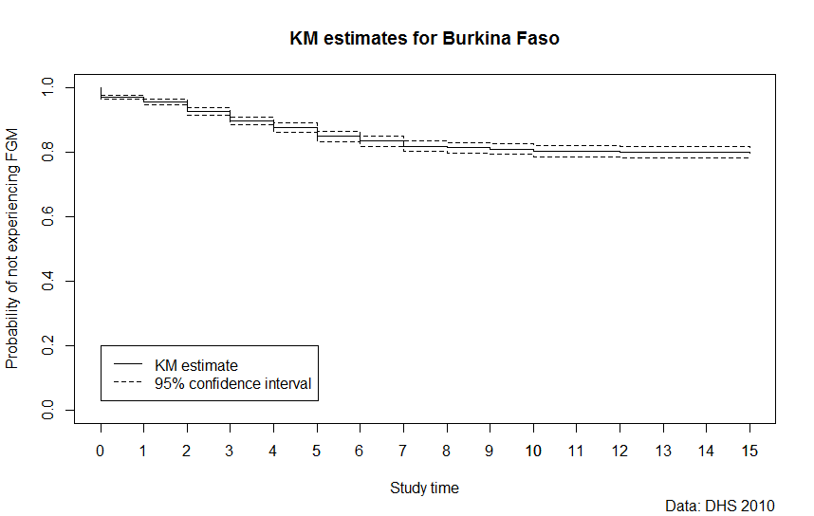

To project the number of girls to be cut each year and in each single-year age cohort from a demographic perspective, the probability of being cut, represented in Figure 2 by the vertical connections of each step, is multiplied by the number of girls alive, in the age group in the specific year, minus the number of girls who had already been cut at an earlier stage.[12] The numbers of girls cut at earlier ages are estimated via deducting the number of girls who have not ‘survived’ until the current period, i. e. who according to the survival function have been cut in previous periods.

In mathematical notation this would be:

fi : Probability of being cut at each year i

Pi j : Female population of age i in year j

Xi j : Estimated amount of girls to be cut at age i in year i

Bi j : Population at risk of age i in year y

In T0:

In Tj:

Note:

New born girls age 0 in any given period j

In the case of Indonesia, the share of girls cut before the age of 1-year was applied to the new age cohort born every year from 2015 to 2030. This is a conservative estimate given that precise age of cutting could not be calculate from the available summary data.

**Software**

The code to read in and modify the data as well as all computations have been implemented in R (<https://cran.r-project.org/>). The Kaplan-Meier estimator was implemented with the survey package, namely the svykm function (Lumley 2018) which provides unbiased estimates for the survival function via a weighted Kaplan-Meier estimator as well as the corresponding standard errors.

**Results**

Analysis of the age specific probabilities of being cut for girls between 0-14 years for each country (except Indonesia) highlights the substantial variation in the age at cutting across high FGM-prevalence countries. Figure 3 a-d depicts these results graphically for the 4 countries with the biggest contribution to the global estimates other than Indonesia. Most girls are cut in the first year of their life in Nigeria, as is the case in Ethiopia albeit at to a lesser extent. In contrast, cutting tends to occur much later for girls in Sudan and also Egypt.

**Figure 3 a-d: Risk of cutting for girls age 0-14 by single year for selected countries**

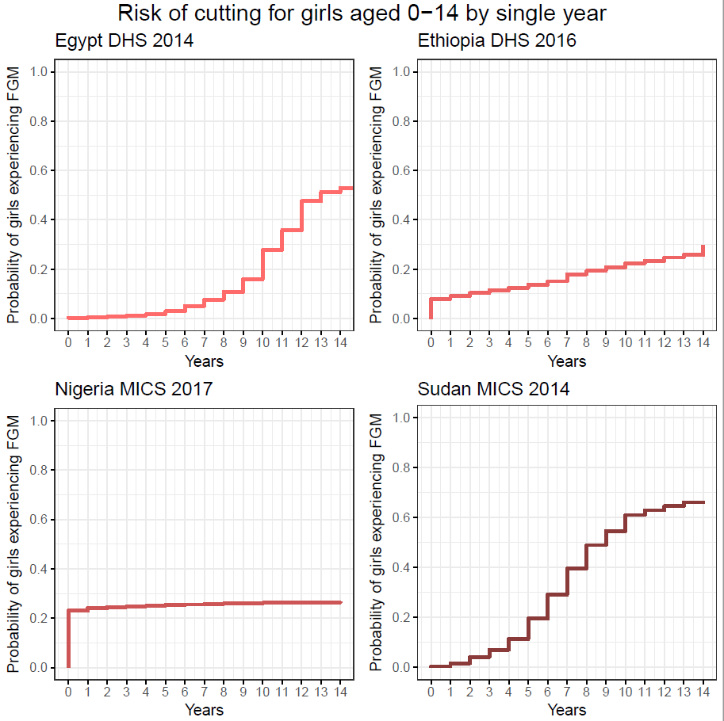

**Table1: Estimates of girls expected to be cut between 2015 and 2030, by country**

|  |  |
| --- | --- |
| **Country** | **No. of Girls (in thousands)** |
| Togo | 12.0 |
| Benin | 19.4 |
| Ghana | 46.2 |
| Central African Republic | 113.3 |
| Tanzania | 136.8 |
| Guinea-Bissau | 161.9 |
| Gambia | 319.9 |
| Sierra Leone | 574.8 |
| Mauritania | 631.7 |
| Senegal | 699.3 |
| Kenya | 813.2 |
| Burkina Faso | 957.0 |
| Iraq | 1,065.3 |
| Cote d'Ivoire | 1,114.6 |
| Chad | 1,146.2 |
| Guinea | 1,749.3 |
| Yemen | 1,897.1 |
| Somalia | 2,174.3 |
| Niger | 2,579.9 |
| Mali | 3,856.5 |
| Sudan | 4,474.7 |
| Ethiopia | 6,286.3 |
| Egypt | 7,143.2 |
| Nigeria | 14,808.5 |
| **Total without Indonesia** | **52,781.2** |
| Indonesia | 15,497.1 |
| **Total with Indonesia** | **68,278.3** |

On a global level, we estimated that the number of girls expected to be cut, who reside in countries for which DHS and MICS survey are available, will increase from just under 3 million in 2015 to 3.7 million in 2030. This estimated increase amounts to 52 million girls for the whole 16-year period, as shown in Figure 4. We arrange the stacked-bars for each year in Figure 3 in ascending order, so that countries with smaller estimated numbers of girls to be cut appear closer to the x-axis and countries with the largest numbers appear in the top portions of each annual stacked bar.

**Figure 4: National estimates – Number of girls expected to be cut, per year, in millions**

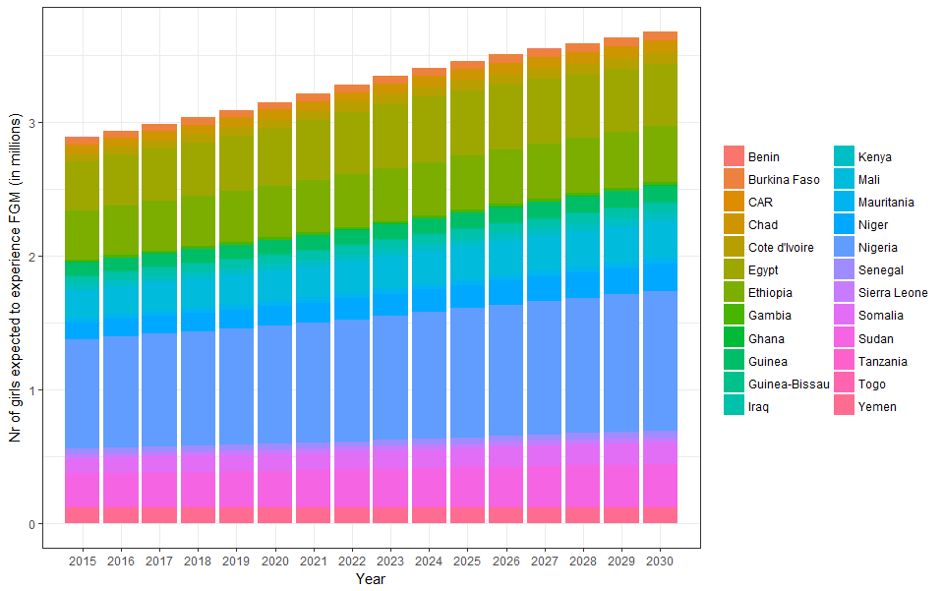

If data on Indonesia is included in the estimates, the annual number of girls to be cut are approximately 1 million girls higher for each year. This amounts to a cumulative total of 68 million girls expected to be cut between 2015 and 2030. In Figure 5, which is structured similarly to Figure 3, we display the annual estimates for Indonesia alongside the survey-based estimates for the 24 countries for which survey microdata are available.

**Figure 5: National estimates (including Indonesia) – Number of girls expected to be cut, per year, in millions** 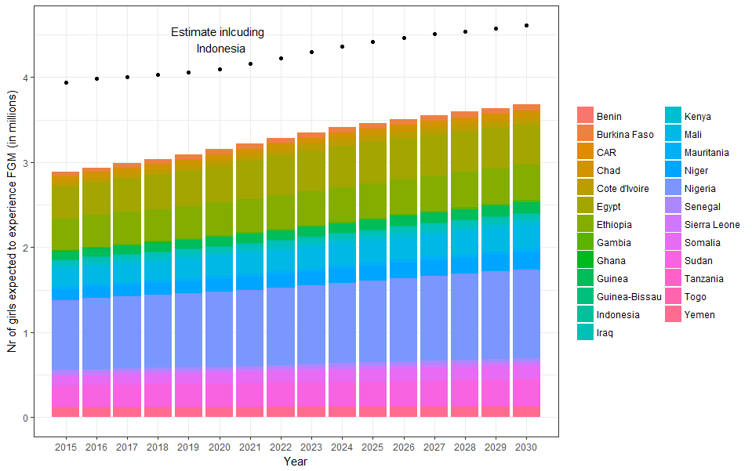

Previous estimates of FGM oscillated around 3 million girls per year (UNICEF 2005; Yoder, Wang and Johansen, 2013; and UNICEF 2013). The estimates presented herein are slightly higher than those previously reported. We discuss the comparison of these estimates with previous estimates in the following section.

Figure 6 illustrates the effect of the level of FGM in a country, depicted on the y -axis, as well as the number of girls age 0-14, depicted on the x-axis, on the contribution of each country to the global estimate, illustrated by the size and color of the bubble bellow. As mentioned earlier, Nigeria, Indonesia, Ethiopia and Egypt contribute to a large extend to the overall number of girls expected to be cut, even though they were not the countries with the highest prevalence in our study. Guinea, Somalia and Mal**i** where FGM is routinely practiced, do not influence the overall estimate to a similar extend. This demonstrate the effect demography has on our estimates.

**Figure 6: Location of girls expected to be cut 2015-2030**

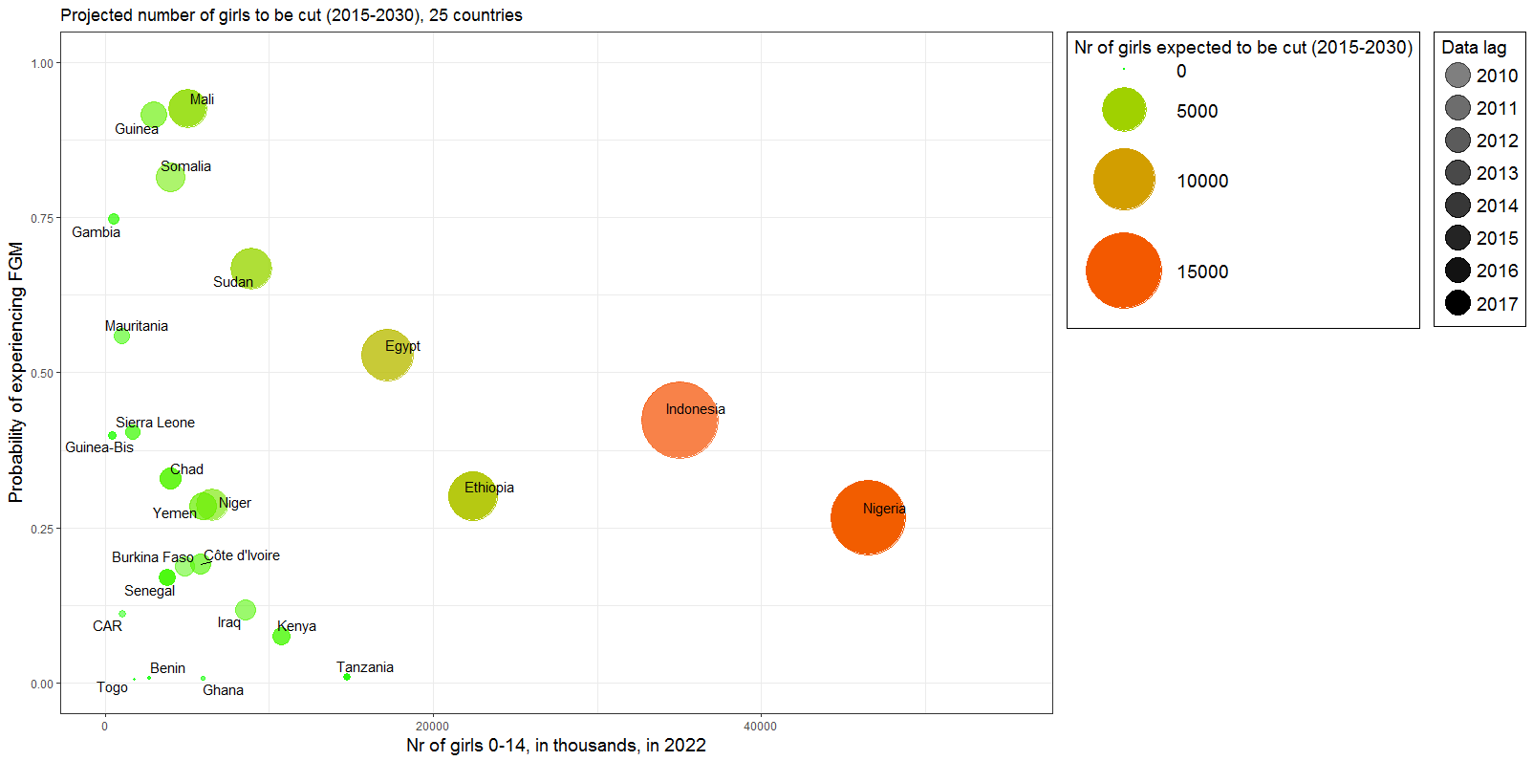

Sources: FGM data - latest nationally representative household survey, and UN DESA, World Population Prospects, 2017 Revision

**Discussion**

In this paper, we presented a new approach to the estimation of FGM risk and affected population size for 25 countries where FGM is documented in nationally representative household surveys. Building on previous estimation efforts, this methodology provides a more precise analysis of the population dynamics surrounding FGM which often assumed implicitly a constant risk of cutting for all cohorts until the age of 20.

The estimates presented in this paper dynamically unpack two core drivers behind the number of girls that will experience FGM in future. The first one is the probability of girls going through FGM at each year of their life, that is the risk of cutting at age 0-years, at age 1-year, at age 2-years, etc.. The second one is the absolute number of girls in each single year cohort, i.e. i. the number of girls aged 0-years, aged 1-year and aged 2-years that are alive. Therefore, our estimates provide an explicit quantification of the effect of future population dynamics on FGM risk girls age 0-14 face in the 25 countries included in this note.

Comparison with Previous Estimates

Our incidence estimates are higher than previous estimates, for two reasons. First, we have cautiously factored in girls cut in the first year of their life in Indonesia, and due to the magnitude of the Indonesian data this adds roughly 1 million girls per year. Second, as we explicitly factor in future population dynamics, our estimates which start around 4 million in 2015, slowly rise to 4.6 in 2030 which is approximately 50% higher than previous estimates. This is true despite the exclusion of Cameroon, Liberia, Uganda, Eritrea and Djibouti from the estimates (more below).

Demography matters, and population size and future population growth are key factors that will shape absolute FGM risk in future years. Hence, we focused explicitly on factoring in these population dynamics into the estimation and modeling process to ensure resulting estimates are sensitive to underlying demographic change and, in turn, shape policy and program design to reduce harmful practices.

Limitations of available data

The data and methods that underpin these estimates are subject to a number of limitations, as a result of the quantity of available data, the nature of these data, and the necessary simplifying assumptions made during the estimation process. We discuss these data limitations in turn below.

Availability of survey data

Nationally-representative data on FGM incidence for all countries of the world are not available and limited to countries targeted in the last 10 years by a MICS or DHS survey that included a FGM module. Hence, this analysis focuses on available data for 25 countries for which this is the case.

Countries such as Cameroon, Djibouti, and Eritrea were not included since there are no recent enough nationally representative surveys that included FGM data. Uganda and Liberia could not be included in the dataset as a question on the age at cutting was not asked during those surveys. Countries that host large numbers of international migrants from places where the FGM is practiced, such as France, Germany, USA, are excluded from this analysis given the lack of data concerning these migrant communities and our focus on countries that are part of the joint UNFPA-UNICEF program on FGM.[13]

We present our estimates initially without data from Indonesia (in Figure 2) and then with data from Indonesia (in Figure 3). We do this for clarity and scientific transparency. The available data from Indonesia are notably less detailed than the DHS and MICS survey microdata published for other countries. The Indonesian RISKESDAS survey data most importantly do not provide specify the year by year disaggregation of age at cutting.[14] However Indonesia, with a projected population size of 264 million persons in 2017, is the 4th most populous country in the world. So excluding Indonesia would highly underestimate the actual number of girls at risk. .

Lack of ‘trend’ or time-series data

At this point, only the most recently available data point was taken into account which is used as the baseline level in 2015 and is assumed to remain constant until 2030. Therefore, the estimates and projections at hand have to be interpreted as number of girls projected to undergo FGM by 2030 if current levels of FGM are to prevail.

As there is evidence of a decline in the practice in many countries (Chikhungu and Madise 2015), future estimates should include this trend and take into account FGM data from successive surveys or different cohorts within the same survey, if they are available and as they hopefully become more available in the near future. We regard this as one of the most important future steps to improve our understanding of the demography of FGM.

Non-availability of data for younger girls

Gambia, Iraq, Niger and Yemen do not collect data on girls younger than 15 years old. When using the data for these countries, the closest age group of women 15-19 years are used in order to estimate the number of girls projected to be cut. Accordingly, the methodology for these countries differs slightly. These young women are either cut, or censored at 15 years as by definition they survived until the age group 15-19 years. How we assume this to influence the data quality, however, is discussed above in the data section.

Respondent recall issues in retrospective survey

If a woman could only vaguely recall when her daughter was cut, or when she was cut, DHS and MICS typically code this as cut ‘During infancy’. In this case, the national survey reports most commonly define ‘infancy’ from 0-5 years. The exact age was estimate by applying the same distribution as observed among women who could remember the exact year of cutting for the respective national survey.

Age-cut off

DHS and MICS surveys interview women age 15-49 who provide information on themselves and, more recently, on their daughters age 14 or younger. As a consequence, the estimates at hand assume that FGM occurs only in the first 14 years of life, and that the status of 14 years old is the final FGM status. This is a reasonable assumption in most cases at hand. Yet, in Kenya a non-negligible amount of FGM occurs after this cut-off.

Uncertainty of the estimates

The estimates at hand are based on nationally representative household surveys as well as population projections by the United Nations and underlie uncertainties that at this point have not yet been quantified. Below, we are listing the factors that lead to or increase uncertainties around the point estimates we presented in this paper.

Non-sampling bias

Both the survey data on FGM and the population projections of girls exposed to the risk of FGM between 2015 and 2030 are subject to measurement uncertainty. The survey data are subject to uncertainty as our estimates are based on a subset of the actual population living in each country which has been sampled by a certain survey design, in the case of DHS, for example, a two stage cluster survey. The population projections used are deterministic projections, but in reality are themselves subject to measurement uncertainty.

Sampling bias - Reliability of survey responses

The estimation of girls/women projected to be cut between 2015 and 2030 assumes that the reporting of FGM by respondents is reliable in the surveys at hand. Inconsistency between data sources may result from language/terminological issues between the interviewer (or survey instrument) and respondent, or changes in the perceived social cultural acceptance, legality, or understanding of FGM amongst survey respondents (UNFPA 2013). This might especially affect the reliability of data derived from mothers’ statements. In some of the countries included in our analysis, such as Burkina Faso, the practice of FGM has been outlawed for many years. Therefore, there might be a disincentive for women to report on the FGM status of their daughters if they are cut. On the other hand, for mothers, the event might date back many years and memories of mothers on their daughter’s childhood might be more reliable compared to memories of their own childhood, taking into account that for a 19 year old, the oldest ‘mother’ cohort included in this estimate, the respondent’s recall period can be as long as 18 years. This is relevant for the four countries included in this estimate for which only data for 15-19 year old have been available.

It is hard to know how reliable respondent reporting is in nationally-representative surveys and the range of variation in survey data reliability across the available surveys. A reliability assessment using successive surveys within Navorongo Health and Demographic Surveillance site in Ghana found that 15% of respondents gave differing responses to FGM questions across the surveys (Jackson et al 2003). In a 2005 small-scale study in rural Northern Tanzania, data from survey responses suggested that 66% of females had experienced FGM in contrast to clinical exam data that implied that 74% had experienced FGM (Klouman, Mangoni, Klepp 2005). Thus additional data and further research is needed to better assess the reliability and validity of responses to survey questions on FGM experience/incidence in different cultural settings.

**Future research directions**

Based on the assessment of limitations of the estimates at hand, we identified some of the most important next steps in order to obtain more precise and reliable incidence estimates on the number of girls at risk of experiencing FGM bellow.

* As an immediate next step, estimates should quantify the non-sampling bias in the household surveys at hand determined by the sampling design, and include an assessment and comparison of data given by women on their own status and experience of FGM as well as the information they provide on their daughters. This analysis should be dynamic in order to factor in changing legislative and social norms in the assessment of the reliability of survey data.
* A thorough analysis of the quantifiable uncertainty around the estimates should be put into context by an analysis on the sensitivity of the methodology based on certain assumptions and test what effect for example the age cut-off or the type of population projection scenario have on the final estimates.
* Estimating the trend of the risk of girls to be cut will be crucial in order to make the estimates more precise and determine if the goal of Agenda 2030 to eliminate FGM will be achievable. While this will be challenging with a handful of countries with only one and many others with no more than three data points, a careful selection of methodology should be applied. .
* In order to truly measure the dynamics of FGM, disaggregation will be crucial. Sub-national estimates, based on the relevant stratifications across wealth, education and other socio-economic characteristics might help to truly unveil the dynamics that shape FGM. Yet, more research on the identification of these covariates is needed in order to successfully implement such an approach. .
* Finally, in order to calculate a truly global estimate, the availability of FGM data should be extended to migrant communities, and countries that have currently been excluded from the analysis due to the lack of recent FGM data.

* In order to achieve all of the above, more data points, more granular surveys and a larger scope of data collections would be necessary.

**Conclusion**

FGM is a harmful practice that both violates basic human rights of women and girls and poses a number of serious physical and mental health risks to them. If FGM practices were to continue at the levels most recently documented, 68 million girls are projected to be cut between 2015 and 2030 in the 25 countries where sufficient data are available. In Indonesia alone, approximately 15 million girls are projected to be cut if the risk of FGM for girls in the first year of their life was to stay the same until 2030. Due to the underlying population dynamics in the countries covered by this estimate, the projected number of girls to be cut each year will increase from 3.9 in 2015 to 4.6 million in 2030.

This analysis of FGM data is the first multi-country initiative to explicitly model the age pattern of cutting when estimating the future FGM risk to girls. It is therefore possible to capture population dynamics in each countries at a more granular level and thus significantly improves estimation precision.

Our estimates imply that even under constant levels of FGM, globally, more and more girls will be affected each year due to the underlying demographics in the countries under consideration. This highlights the importance of factoring in underlying population dynamics when estimating  
FGM risk. It also demonstrates that increased efforts are required in order to halt this trend.

**Literature**

Adeokun, Lawrence, Modupe Oduwole, Frank Oronsaye, AO Gbogboade, Nurudeen Aliyu, Wumi Adekunle, Grace Sadiq, Ireti Sutton, and Modupe Taiwo. “Trends in Female Circumcision Between 1933 And 2003 in Osun And Ogun States, Nigeria: A Cohort Analysis.” *African Journal of Reproductive Health* 10, no. 2 (2006): pp. 48-56. url: <https://www.ajol.info/index.php/ajrh/article/view/7885>

Chikhungu, LC and NJ Madise. “Trends and protective factors of female genital mutilation in Burkina Faso: 1999 to 2010.” *International Journal for Equity in Health* (2015): 14-42. doi: 10.1186/s12939-015-0171-1

Demographic and Health Surveys (DHS). “DHS Questionnaires and Modules.” url: <https://dhsprogram.com/publications/publication-DHSQM-DHS-Questionnaires-and-Manuals.cfm>

Fagbamigbe AF, AS Adebowale , I. Morhason-Bello. “Survival analysis of time to uptake of modern contraceptives among sexually active women of reproductive age in Nigeria.”

*BMJ Open 5(2015)*. doi: 10.1136/bmjopen-2015-008371

Horvitz, D. G., D. J. Thompson. “A Generalization of Sampling Without Replacement From a Finite Universe.“ *Journal of the American Statistical Association* 47, no. 260 (1952): 663-685

Jackson, E.E., P. Akweongo, E. Sakeah, A. Hodgson, R. Asuru, and J.E. Phillips. “Inconsistent Reporting of Female Genital Cutting Status in Northern Ghana: Explanatory Factors and Analytical Consequences.” *Studies in Family Planning* 34, no. 3 (2003): 200-210. doi: 10.1111/j.1728-4465.2003.00200.x

Johnsdotter, Sarah, and Birgitta Essen. “Cultural change after migration: Circumcision of girls in Western migrant communities.” *Best Practice and Research Clinical Obstetrics and Gynaecology - special issue on Migration - Impact on Reproductive Health* 32 (2015): 15-25. doi: <https://doi.org/10.1016/j.bpobgyn.2015.10.012>

Goldberg, Howard, Paul Stupp, Ekwutosi Okoroho, Ghenet Besera, David Goodman, and Isabella Danel. “Female Genital Mutilation/Cutting in the United States: Updated Estimates of Women and Girls at Risk.” *Public Health Reports* 131, no. 2 (2012): 340-347. url: <http://journals.sagepub.com/doi/abs/10.1177/003335491613100218?journalCode=phrg>

Kaplan E., P. Meier. “Nonparametric estimation from incomplete observation.” Journal of the American Statistical Association 53. no.282(1958) :457-481, doi:[10.2307/2281868](https://doi.org/10.2307%2F2281868)

Klouman, Elise, Rachel Manongi, and Knut-Inge Klepp, “Self-reported and Observed Female Genital Cutting in Rural Tanzania: Associated Demographic Factors, HIV and Sexually Transmitted Infections.” *Tropical Medicine and International Health* 10, no. 1 (2005): 105-115. doi: [10.1111/j.1365-3156.2004.01350.x](https://doi.org/10.1111/j.1365-3156.2004.01350.x)

Leye, Els, Lut Mergaert, Catarina Arnaut, Sioban O’Brien Green. “Towards a better estimation of prevalence of female genital mutilation in the European Union: interpreting existing evidence in all EU Member States.” *Genus* 70, no. 1 (2014): 99-121. url: <http://www.jstor.org/stable/genus.70.1.99>

Lumley, Thomas. “Package ‘survey - Analysis of Complex Survey Samples’.” (2018). url: <https://cran.r-project.org/web/packages/survey/survey.pdf>

Shell-Duncan, Bettina. “Considerations on the Use and Interpretation of Survey Data on FGM/C.” *Evidence to End FGM/C: Research to Help Women Thrive*, New York: Population Council, 2016

Macfarlane, A. J. and E. Dorkenoo. “Female Genital Mutilation in England and Wales: Updated statistical estimates of the numbers of affected women living in England and Wales and girls at risk Interim report on provisional estimates.” London: City University London, 2014. url: <http://openaccess.city.ac.uk/3865/1/Female%20Genital%20Mutilation%20in%20England%20and%20Wales.pdf>

Ortesni, Livia Elisa, Patrizia Farina and Alessio Menonna. “Improving estimates of the prevalence of Female Genital Mutilation/Cutting among migrants in Western countries.” *Demographic Research* 32, no. 18(2015): 543-562. doi: 10.4054/DemRes.2015.32.18

Rebora, Paola, Maria Grazia Valsecchi. “Survival estimation in two-phase cohort studies with application to biomarkers evaluation.” *Statistical Methods in Medical Research* 25, no. 16(2016):2895-2908. doi: 10.1177/0962280214534411

Rutstein, Shea Oscar, Guillermo Rojas. *Guide to DHs Statistics*. Calverton, Maryland (2006)

Saerndal CE and B. Swensson. “General view of estimation for two phases of selection with applications to two-phase sampling and nonresponse.” International Statistical Review 55 (1987): 279-294.

UNFPA. “Driving Forces in Outlawing the Practice of Female Genital Mutilation/Cutting in Kenya, Uganda and Guinea-Bissau.” New York: UNFPA/UNICEF, 2013. url: <https://www.unfpa.org/sites/default/files/resource-pdf/Legislation%20and%20FGMC.pdf>

UNFPA. “Female Genital Mutilation.” February 6 2018, <http://www.unfpa.org/female-genital-mutilation>

[UNFPA. “UNFPA-UNICEF Joint Programme to Eliminate Female Genital Mutilation.” February 6 2018.](http://www.unfpa.org/female-genital-mutilation) <https://www.unfpa.org/unfpa-unicef-joint-programme-eliminate-female-genital-mutilation>

UNICEF. “Press release - Three million girls undergo female genital cutting every year.” 23 November 2005, <https://www.unicef.org/media/media_30047.html>

UNICEF. “Female Genital Mutilation - A Global Concern.” February 3 2016, <https://www.unicef.org/media/files/FGMC_2016_brochure_final_UNICEF_SPREAD.pdf>

UNICEF. “Sexual and reproductive heath, Female genital mutilation (FGM).” 2013, <http://www.who.int/reproductivehealth/topics/fgm/prevalence/en/>

UNICEF. “Questionnaire for Individual Women.” 29 November 2017, <http://mics.unicef.org/tools>

United Nations. “United Nations Resolution A/RES/69/150.” 17 February 2015, <http://www.un.org/en/ga/search/view_doc.asp?symbol=A/RES/69/150>

United Nations. “United Nations Resolution A/RES/67/146.” 5 March 2013, <http://www.un.org/en/ga/search/view_doc.asp?symbol=A/RES/67/146>

United Nations. “Annex: Resolution adopted by the General Assembly on Work of the Statistical Commission pertaining to the 2030 Agenda for Sustainable Development (A/RES/71/313).” 10 July 2017, <https://undocs.org/A/RES/71/313>

Yoder, Stanley, Shanxiao Wang, and Elise Johansen. “Estimates of Female Genital Mutilation/Cutting in 27 African Countries and Yemen.” *Studies in Family Planning* 44, no 2(2013): 189–204. doi:10.1111/j.1728-4465.2013.00352.x

WHO. “Eliminating Female genital mutilation An interagency statement OHCHR, UNAIDS, UNDP, UNECA, UNESCO, UNFPA, UNHCR, UNICEF, UNIFEM, WHO.” 2008, <http://apps.who.int/iris/bitstream/10665/43839/1/9789241596442_eng.pdf>

**Annex I**

## **Table 1: National Household Survey Data used for FGM Estimates, 2010-2016**

|  |  |  |  |  |
| --- | --- | --- | --- | --- |
| No. | Country | Survey | Year | Comments |
| 1 | Benin | MICS | 2014 | 18 cases of FGM among daughters |
| 2 | Burkina Faso | DHS | 2010 |  |
| 3 | Cameroon | - | - | DHS 2004 out of scope, given surveys only conducted since 2010 were included in analysis |
| 4 | Central African Republic | MICS | 2010 |  |
| 5 | Chad | DHS | 2014-2015 |  |
| 6 | Cote d’Ivoire | DHS | 2011-2012 |  |
| 7 | Djibouti | - | - | DHS 2006 out of scope, given surveys only conducted since 2010 were included in analysis |
| 8 | Egypt | DHS | 2014 | Data for daughters were collected until 19, but in this methodology only data until 14 are used |
| 9 | Eritrea | - | - | DHS out of scope, given surveys only conducted since 2010 were included in analysis |
| 10 | Ethiopia | DHS | 2016 |  |
| 11 | Gambia | DHS | 2013 | The MICS 2010 dataset was not yet available, the DHS 2013 did not contain the module on daughters (missing variables GIDX, G122-G124)  Data for women age 15-19 were used  95=During infancy (<5 according to DHS report), but not in 15-19 data set |
| 12 | Ghana | MICS | 2011 |  |
| 13 | Guinea | DHS | 2012 |  |
| 14 | Guinea-Bissau | MICS | 2014 |  |
| 15 | Indonesia | RISKESDAS | 2013 | Data on age at cutting were not collected by single-year and micro dataset not available at this point, please refer to attached methodology |
| 16 | Iraq | MICS | 2011 | Does not contain full module on FGM on daughters, Data for women age 15-19 were used  95 during infancy  True for 5 observations in dataset |
| 17 | Kenya | DHS | 2014 |  |
| 18 | Liberia | - | - | Women are only asked if they know and are a member of the Sande society |
| 19 | Mali | MICS | 2015 |  |
| 20 | Mauritania | MICS | 2011 | Micro dataset of 2015 MICS not available yet  Age at cutting (FG16) was collected in days, months and years |
| 21 | Niger | DHS | 2012 | 95= during infancy, in report before 5  Does not contain full module on FGM on daughters, Data for women age 15-19 were used |
| 22 | Nigeria | MICS | 2016-2017 |  |
| 23 | Senegal | DHS | 2016 |  |
| 24 | Sierra Leone | MICS | 2010 | DHS 2013 does not contain full module on FGM on daughters |
| 25 | Somalia | MICS | 2011 | Somaliland, and Somalia Northeastern Zone were estimated separately, a mean was used for the national estimate |
| 26 | Sudan | MICS | 2014 |  |
| 27 | Tanzania | DHS | 2015-2016 |  |
| 28 | Togo | DHS | 2013-2014 |  |
| 29 | Uganda | - | - | Age at circumcision was not recorded in DHS 2011 |
| 30 | Yemen | DHS | 2013 | 95 = During infancy in DHS report only reported as one year or older (I do not see it in dataset for 15-19)  93 = During the first week  94 = After first week but in first year  Does not contain full module on FGM on daughters, Data for women age 15-19 were used |

## **Annex II**

**Figure 4: Kaplan Meier Survival Curve for FGM in Benin**

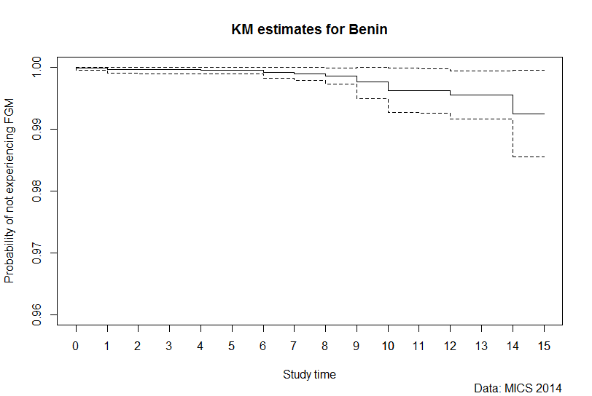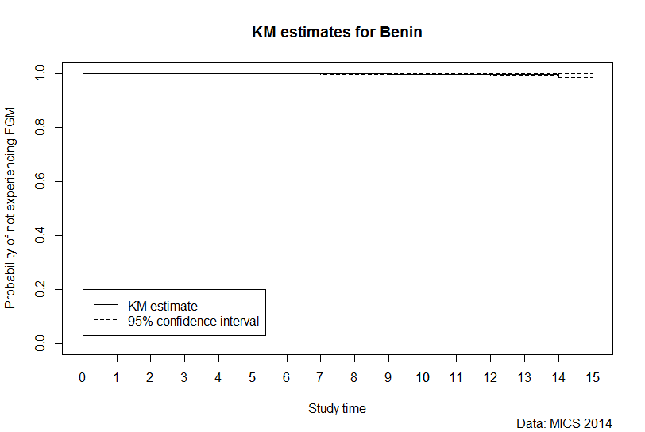

|  |  |  |  |
| --- | --- | --- | --- |
| Study time | Point estimate | Confidence interval (lower) | Confidence interval (upper) |
| 0 | 0.99975 | 0.999493 | 1 |
| 1 | 0.99949 | 0.998988 | 1 |
| 2 | 0.99947 | 0.998949 | 1 |
| 3 | 0.99947 | 0.998949 | 1 |
| 4 | 0.99944 | 0.998884 | 1 |
| 5 | 0.99944 | 0.998884 | 1 |
| 6 | 0.99912 | 0.998261 | 0.999976 |
| 7 | 0.99891 | 0.997824 | 1 |
| 8 | 0.99855 | 0.997258 | 0.999843 |
| 9 | 0.99749 | 0.994978 | 1 |
| 10 | 0.99625 | 0.992649 | 0.999853 |
| 11 | 0.99617 | 0.992546 | 0.999789 |
| 12 | 0.99548 | 0.991624 | 0.999341 |
| 13 | 0.99548 | 0.991624 | 0.999341 |
| 14 | 0.99248 | 0.985475 | 0.999487 |
| 15 | 0.99248 | 0.985475 | 0.999487 |

**Figure 5: Kaplan Meier Survival Curve for FGM in Burkina Faso**



|  |  |  |  |  |
| --- | --- | --- | --- | --- |
| Study time | | Point estimate | Confidence interval (lower) | Confidence interval (upper) |
| 0 | 0.97138635 | | 0.9654857 | 0.977287 |
| 1 | 0.95548265 | | 0.94707 | 0.9638953 |
| 2 | 0.9258171 | | 0.9144679 | 0.9371663 |
| 3 | 0.8963247 | | 0.8834011 | 0.9092483 |
| 4 | 0.8757423 | | 0.8615193 | 0.8899653 |
| 5 | 0.84855915 | | 0.8331975 | 0.8639208 |
| 6 | 0.83427685 | | 0.8182521 | 0.8503016 |
| 7 | 0.8183323 | | 0.8018554 | 0.8348092 |
| 8 | 0.8133522 | | 0.7966933 | 0.8300111 |
| 9 | 0.8093497 | | 0.7925327 | 0.8261667 |
| 10 | 0.80237305 | | 0.7849435 | 0.8198026 |
| 11 | 0.80131335 | | 0.7838474 | 0.8187793 |
| 12 | 0.8003372 | | 0.7827916 | 0.8178828 |
| 13 | 0.7996941 | | 0.782088 | 0.8173002 |
| 14 | 0.7996941 | | 0.782088 | 0.8173002 |

**Figure 6: Kaplan Meier Survival Curve for FGM in Central African Republic**

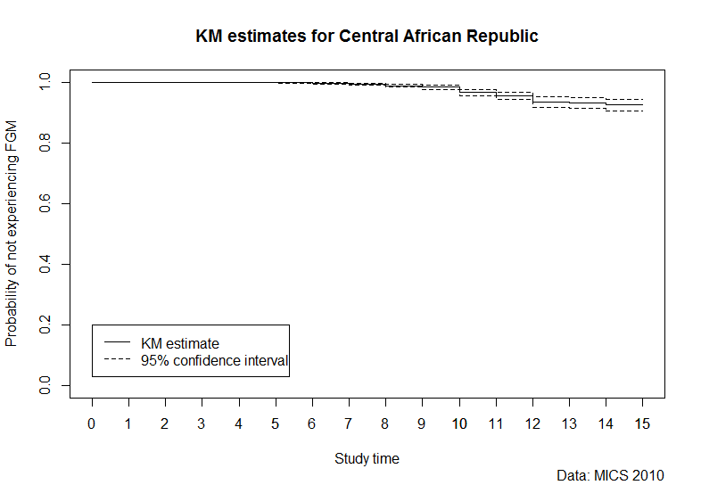

|  |  |  |  |
| --- | --- | --- | --- |
| Study time | Point estimate | Confidence interval (lower) | Confidence interval (upper) |
| 0 | 1 | 1 | 1 |
| 1 | 1 | 1 | 1 |
| 2 | 0.999779 | 0.99956 | 1 |
| 3 | 0.999686 | 0.99937 | 1 |
| 4 | 0.999639 | 0.99928 | 1 |
| 5 | 0.998258 | 0.99662 | 0.999891 |
| 6 | 0.995858 | 0.99332 | 0.998398 |
| 7 | 0.994914 | 0.99212 | 0.997706 |
| 8 | 0.988949 | 0.98424 | 0.993661 |
| 9 | 0.983444 | 0.97736 | 0.989524 |
| 10 | 0.965905 | 0.95555 | 0.976263 |
| 11 | 0.95494 | 0.94244 | 0.967438 |
| 12 | 0.935322 | 0.91848 | 0.952161 |
| 13 | 0.931193 | 0.91357 | 0.948818 |
| 14 | 0.925247 | 0.90558 | 0.944911 |
| 15 | 0.925247 | 0.905584 | 0.944911 |

**Figure 7: Kaplan Meier Survival Curve for FGM in Chad**

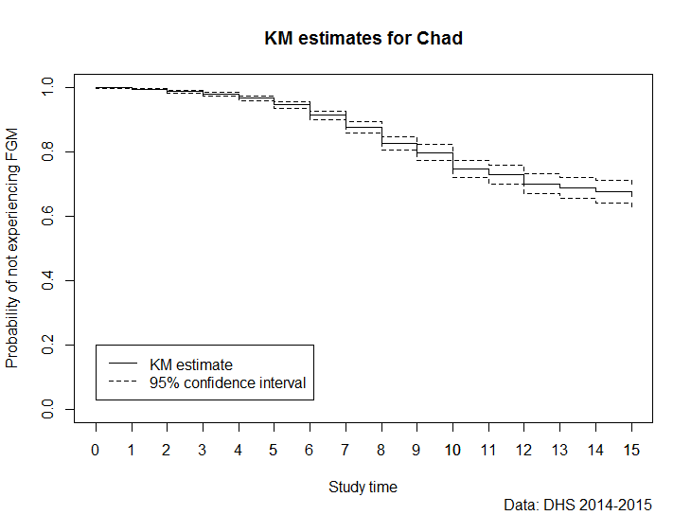

|  |  |  |  |
| --- | --- | --- | --- |
| Study time | Point estimate | Confidence interval (lower) | Confidence interval (upper) |
| 0 | 0.99807 | 0.997112 | 0.999024 |
| 1 | 0.99463 | 0.992667 | 0.996587 |
| 2 | 0.98627 | 0.982422 | 0.990125 |
| 3 | 0.97799 | 0.972619 | 0.98336 |
| 4 | 0.96606 | 0.958641 | 0.973477 |
| 5 | 0.94593 | 0.935646 | 0.95621 |
| 6 | 0.91346 | 0.899779 | 0.927135 |
| 7 | 0.87519 | 0.857682 | 0.892696 |
| 8 | 0.82632 | 0.805447 | 0.847194 |
| 9 | 0.79804 | 0.77444 | 0.821646 |
| 10 | 0.7465 | 0.719428 | 0.773575 |
| 11 | 0.72841 | 0.69985 | 0.756975 |
| 12 | 0.7016 | 0.670576 | 0.732629 |
| 13 | 0.68843 | 0.656563 | 0.720289 |
| 14 | 0.67607 | 0.641039 | 0.711109 |

**Figure 8: Kaplan Meier Survival Curve for FGM in Cote d’Ivoire**

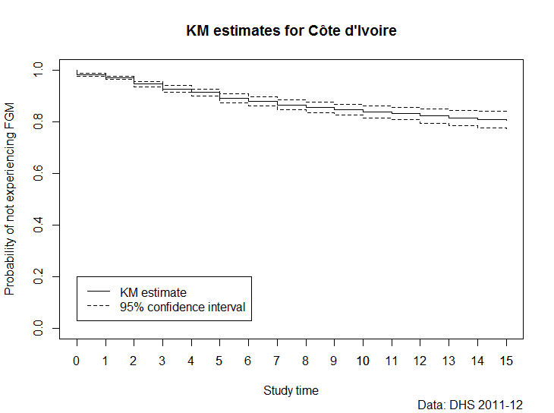

|  |  |  |  |
| --- | --- | --- | --- |
| Study time | Point estimate | Confidence interval (lower) | Confidence interval (upper) |
| 0 | 0.98216 | 0.97648 | 0.987845 |
| 1 | 0.9699 | 0.96316 | 0.976637 |
| 2 | 0.94583 | 0.935354 | 0.956313 |
| 3 | 0.92633 | 0.913217 | 0.939438 |
| 4 | 0.9131 | 0.899058 | 0.927142 |
| 5 | 0.89106 | 0.874368 | 0.907746 |
| 6 | 0.88 | 0.861953 | 0.898052 |
| 7 | 0.86522 | 0.845988 | 0.884443 |
| 8 | 0.85466 | 0.834299 | 0.875026 |
| 9 | 0.84728 | 0.826053 | 0.868503 |
| 10 | 0.83742 | 0.814385 | 0.860445 |
| 11 | 0.8318 | 0.807039 | 0.85657 |
| 12 | 0.8227 | 0.795105 | 0.850289 |
| 13 | 0.81381 | 0.783956 | 0.843672 |
| 14 | 0.80775 | 0.776158 | 0.839336 |

**Figure 9: Kaplan Meier Survival Curve for FGM in Egypt**

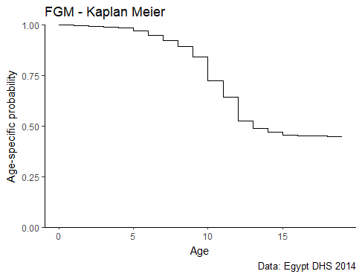

Forthcoming

**Figure 10: Kaplan Meier Survival Curve for FGM in Ethiopia**

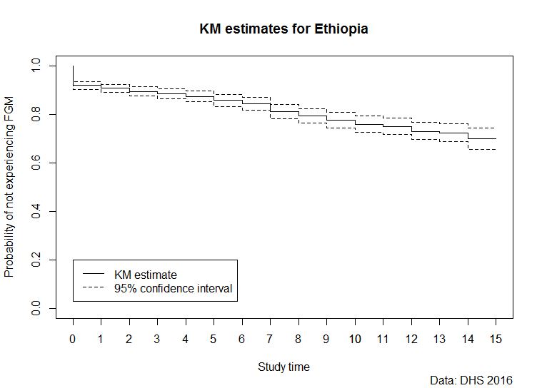

|  |  |  |  |
| --- | --- | --- | --- |
| Study time | Point estimate | Confidence interval (lower) | Confidence interval (upper) |
| 0 | 0.919531 | 0.90377 | 0.93529 |
| 1 | 0.907592 | 0.89106 | 0.924129 |
| 2 | 0.895037 | 0.87708 | 0.912996 |
| 3 | 0.883843 | 0.86301 | 0.904681 |
| 4 | 0.873873 | 0.85133 | 0.896411 |
| 5 | 0.857989 | 0.83318 | 0.882796 |
| 6 | 0.843621 | 0.81778 | 0.869463 |
| 7 | 0.810909 | 0.78188 | 0.839944 |
| 8 | 0.792977 | 0.7631 | 0.822859 |
| 9 | 0.776444 | 0.74479 | 0.808096 |
| 10 | 0.759654 | 0.72694 | 0.792368 |
| 11 | 0.751418 | 0.71758 | 0.785256 |
| 12 | 0.731271 | 0.69601 | 0.766535 |
| 13 | 0.723807 | 0.687048 | 0.760565 |
| 14 | 0.700659 | 0.65658 | 0.744738 |

**Figure 11: Kaplan Meier Survival Curve for FGM in Gambia**

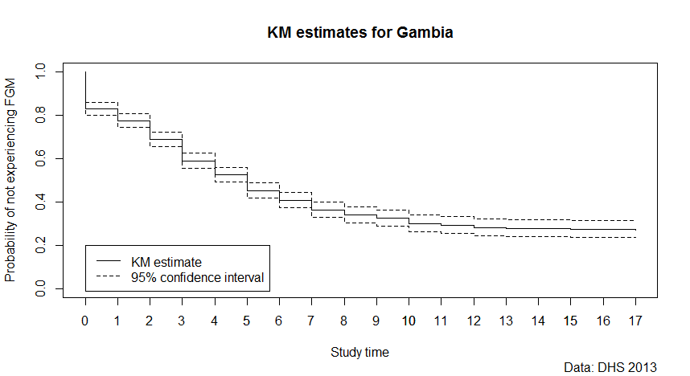

|  |  |  |  |
| --- | --- | --- | --- |
| Study time | Point estimate | Confidence interval (lower) | Confidence interval (upper) |
| 0 | 0.82837 | 0.798463 | 0.858274 |
| 1 | 0.77566 | 0.743276 | 0.80804 |
| 2 | 0.68846 | 0.654191 | 0.72273 |
| 3 | 0.59039 | 0.55557 | 0.625205 |
| 4 | 0.52592 | 0.49191 | 0.559938 |
| 5 | 0.45378 | 0.419835 | 0.487732 |
| 6 | 0.40749 | 0.372625 | 0.442351 |
| 7 | 0.36538 | 0.329574 | 0.401179 |
| 8 | 0.34094 | 0.304322 | 0.377561 |
| 9 | 0.32645 | 0.288577 | 0.364329 |
| 10 | 0.30071 | 0.261701 | 0.339717 |
| 11 | 0.29286 | 0.253691 | 0.332036 |
| 12 | 0.28317 | 0.244794 | 0.321547 |
| 13 | 0.27845 | 0.240324 | 0.316577 |
| 14 | 0.27818 | 0.240017 | 0.316334 |
| 15 | 0.27469 | 0.236142 | 0.313232 |
| 16 | 0.27452 | 0.235974 | 0.313073 |
| 17 | 0.27362 | 0.234942 | 0.312288 |
| 18 | 0.27362 | 0.234942 | 0.312288 |
| 19 | 0.27362 | 0.234942 | 0.312288 |

**Figure 12: Kaplan Meier Survival Curve for FGM in Ghana**

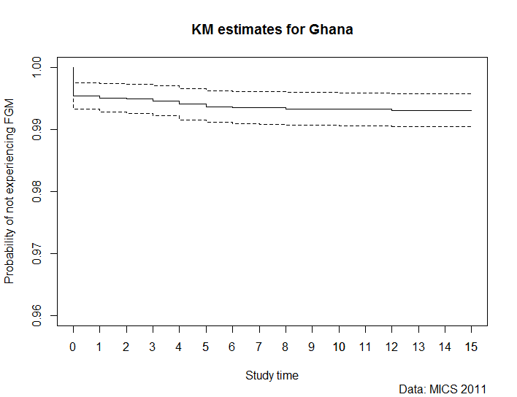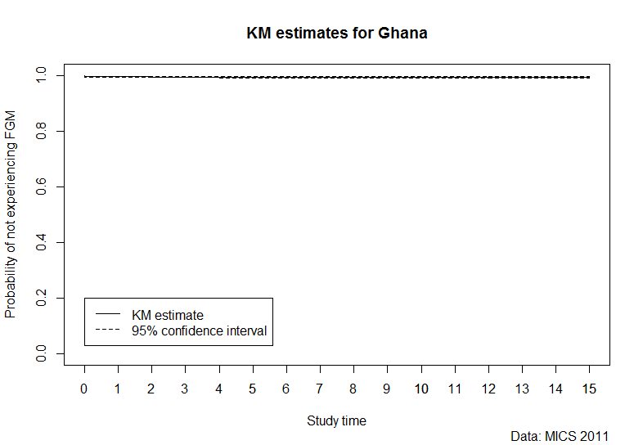

|  |  |  |  |
| --- | --- | --- | --- |
| Study time | Point estimate | Confidence interval (lower) | Confidence interval (upper) |
| 0 | 0.995366 | 0.993224 | 0.99751 |
| 1 | 0.995088 | 0.992822 | 0.99735 |
| 2 | 0.994902 | 0.992568 | 0.99724 |
| 3 | 0.99462 | 0.992246 | 0.99699 |
| 4 | 0.994065 | 0.991552 | 0.99658 |
| 5 | 0.993683 | 0.991108 | 0.99626 |
| 6 | 0.993501 | 0.990898 | 0.9961 |
| 7 | 0.993471 | 0.990862 | 0.99608 |
| 8 | 0.993337 | 0.990719 | 0.99595 |
| 9 | 0.993337 | 0.990719 | 0.99595 |
| 10 | 0.993243 | 0.990617 | 0.99587 |
| 11 | 0.993243 | 0.990617 | 0.99587 |
| 12 | 0.993092 | 0.990447 | 0.99574 |
| 13 | 0.993092 | 0.990447 | 0.99574 |
| 14 | 0.993092 | 0.990447 | 0.995736 |
| 15 | 0.993092 | 0.990447 | 0.995736 |

**Figure 13: Kaplan Meier Survival Curve for FGM in Guinea**

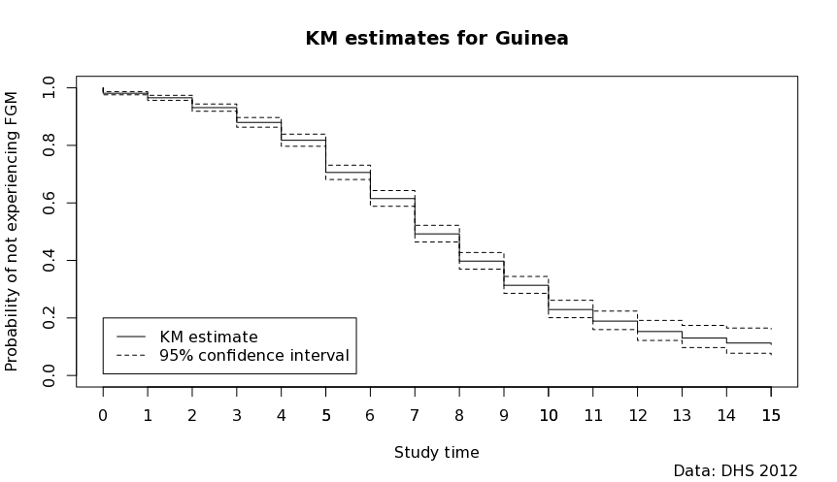

|  |  |  |  |
| --- | --- | --- | --- |
| Study time | Point estimate | Confidence interval (lower) | Confidence interval (upper) |
| 0 | 0.981066 | 0.975652 | 0.98648 |
| 1 | 0.965308 | 0.956658 | 0.973957 |
| 2 | 0.931208 | 0.918615 | 0.943802 |
| 3 | 0.879945 | 0.86303 | 0.89686 |
| 4 | 0.817982 | 0.79682 | 0.839144 |
| 5 | 0.70628 | 0.681353 | 0.731207 |
| 6 | 0.615468 | 0.588152 | 0.642784 |
| 7 | 0.493141 | 0.46424 | 0.522043 |
| 8 | 0.398582 | 0.369709 | 0.427456 |
| 9 | 0.315019 | 0.285744 | 0.344294 |
| 10 | 0.231234 | 0.200952 | 0.261516 |
| 11 | 0.191761 | 0.159573 | 0.223948 |
| 12 | 0.156795 | 0.121945 | 0.191646 |
| 13 | 0.135784 | 0.097252 | 0.174316 |
| 14 | 0.121191 | 0.077313 | 0.165068 |
| 15 | 0.116688 | 0.071699 | 0.161676 |

**Figure 14: Kaplan Meier Survival Curve for FGM in Guinea-Bissau**

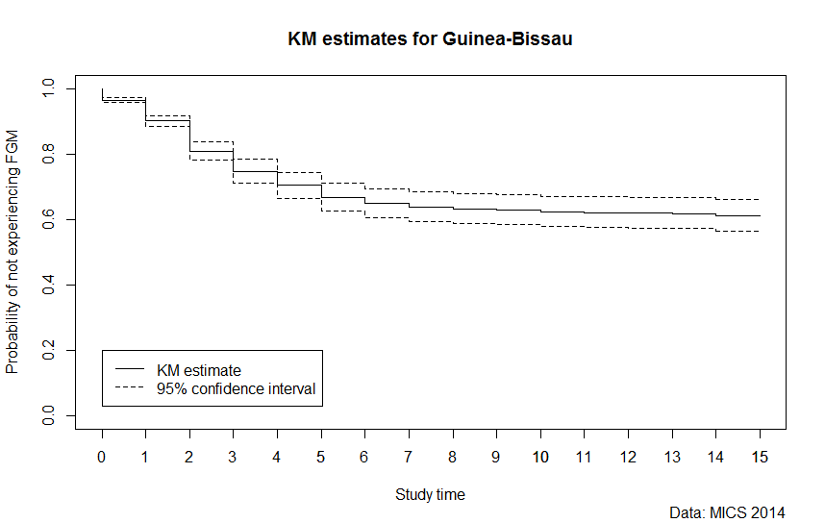

|  |  |  |  |
| --- | --- | --- | --- |
| Study time | Point estimate | Confidence interval (lower) | Confidence interval (upper) |
| 0 | 0.965225 | 0.957691 | 0.97276 |
| 1 | 0.901435 | 0.885395 | 0.917476 |
| 2 | 0.809557 | 0.781178 | 0.837937 |
| 3 | 0.747378 | 0.710946 | 0.783811 |
| 4 | 0.705294 | 0.6657 | 0.744889 |
| 5 | 0.668929 | 0.625845 | 0.712014 |
| 6 | 0.65047 | 0.606354 | 0.694586 |
| 7 | 0.638521 | 0.593572 | 0.68347 |
| 8 | 0.633794 | 0.588206 | 0.679381 |
| 9 | 0.631366 | 0.585299 | 0.677432 |
| 10 | 0.623922 | 0.577653 | 0.670192 |
| 11 | 0.622396 | 0.576015 | 0.668778 |
| 12 | 0.621061 | 0.574442 | 0.66768 |
| 13 | 0.620197 | 0.573516 | 0.666878 |
| 14 | 0.612613 | 0.563745 | 0.661481 |
| 15 | 0.612613 | 0.563745 | 0.661481 |

**Figure 15: Kaplan Meier Survival Curve for FGM in Iraq**

## 

|  |  |  |  |  |
| --- | --- | --- | --- | --- |
| Study time | Point estimate | Confidence interval (lower) | Confidence interval (upper) | |
| 0 | 1 | 1 | | 1 |
| 1 | 0.998395 | 0.997509 | | 0.99928 |
| 2 | 0.992268 | 0.988907 | | 0.995629 |
| 3 | 0.977886 | 0.971208 | | 0.984565 |
| 4 | 0.953902 | 0.941509 | | 0.966295 |
| 5 | 0.923826 | 0.908284 | | 0.939368 |
| 6 | 0.910185 | 0.893199 | | 0.92717 |
| 7 | 0.899886 | 0.881557 | | 0.918216 |
| 8 | 0.893292 | 0.874551 | | 0.912033 |
| 9 | 0.888972 | 0.869517 | | 0.908426 |
| 10 | 0.887362 | 0.867846 | | 0.906879 |
| 11 | 0.886106 | 0.866223 | | 0.90599 |
| 12 | 0.885321 | 0.865402 | | 0.905241 |
| 13 | 0.884038 | 0.864047 | | 0.904029 |
| 14 | 0.883906 | 0.863914 | | 0.903899 |
| 15 | 0.883691 | 0.863695 | | 0.903687 |

**Figure 16: Kaplan Meier Survival Curve for FGM in Kenya**

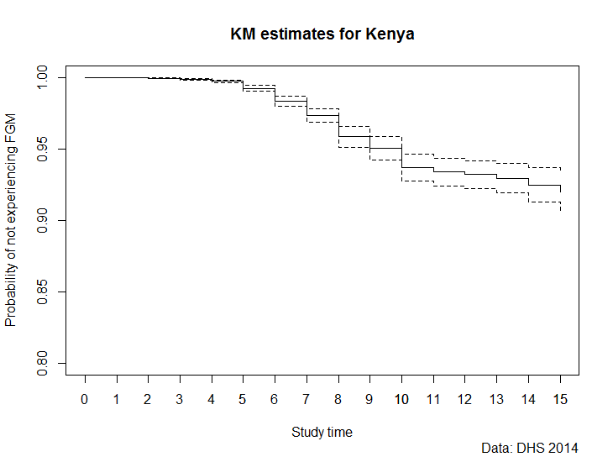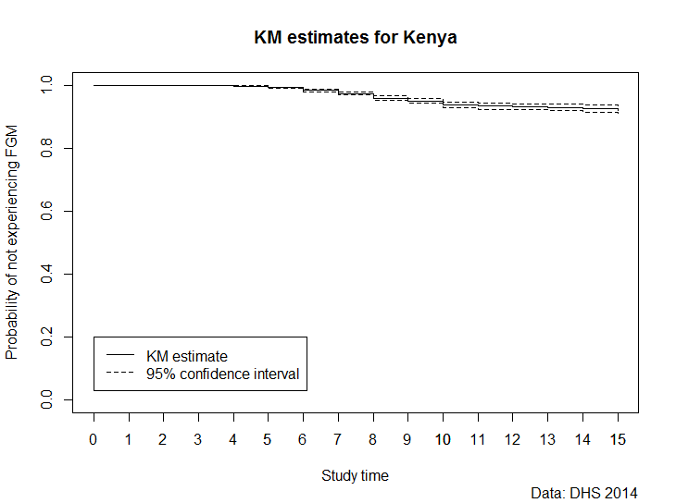

|  |  |  |  |
| --- | --- | --- | --- |
| Study time | Point estimate | Confidence interval (lower) | Confidence interval (upper) |
| 0 | 0.99988 | 0.999761 | 1 |
| 1 | 0.99982 | 0.999655 | 0.999994 |
| 2 | 0.99956 | 0.999229 | 0.999901 |
| 3 | 0.99878 | 0.998154 | 0.999403 |
| 4 | 0.99735 | 0.996381 | 0.99831 |
| 5 | 0.9925 | 0.990249 | 0.994756 |
| 6 | 0.98357 | 0.980162 | 0.986984 |
| 7 | 0.97351 | 0.968867 | 0.978155 |
| 8 | 0.95869 | 0.951373 | 0.966006 |
| 9 | 0.95055 | 0.942542 | 0.958548 |
| 10 | 0.93712 | 0.927715 | 0.946523 |
| 11 | 0.93388 | 0.924183 | 0.94357 |
| 12 | 0.93216 | 0.922416 | 0.941903 |
| 13 | 0.92967 | 0.919581 | 0.939758 |
| 14 | 0.92486 | 0.912822 | 0.936889 |

**Figure 17: Kaplan Meier Survival Curve for FGM in Mali**

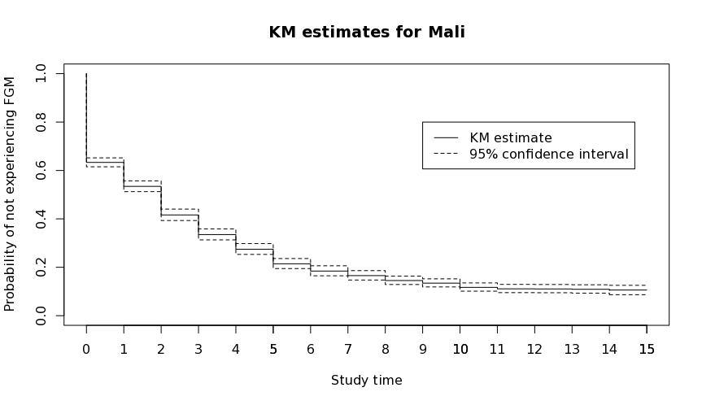

|  |  |  |  |
| --- | --- | --- | --- |
| Study time | Point estimate | Confidence interval (lower) | Confidence interval (upper) |
| 0 | 0.63368 | 0.615258 | 0.652103 |
| 1 | 0.534846 | 0.512573 | 0.557118 |
| 2 | 0.416803 | 0.393139 | 0.440466 |
| 3 | 0.33583 | 0.313058 | 0.358601 |
| 4 | 0.275514 | 0.25305 | 0.297977 |
| 5 | 0.215357 | 0.194547 | 0.236167 |
| 6 | 0.185389 | 0.164758 | 0.20602 |
| 7 | 0.166686 | 0.147266 | 0.186105 |
| 8 | 0.146129 | 0.128687 | 0.163572 |
| 9 | 0.135367 | 0.118644 | 0.15209 |
| 10 | 0.118208 | 0.101097 | 0.135319 |
| 11 | 0.112155 | 0.095115 | 0.129195 |
| 12 | 0.111754 | 0.0947 | 0.128808 |
| 13 | 0.110383 | 0.093047 | 0.127719 |
| 14 | 0.10596 | 0.086586 | 0.125333 |
| 15 | 0.10596 | 0.086586 | 0.125333 |

**Figure 18: Kaplan Meier Survival Curve for FGM in Mauritania**

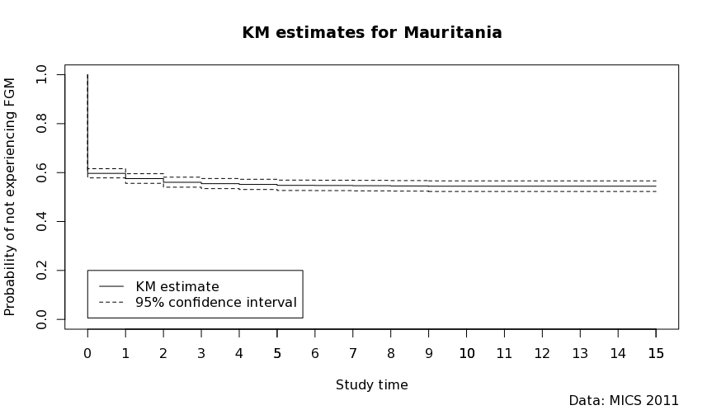

|  |  |  |  |
| --- | --- | --- | --- |
| Study time | Point estimate | Confidence interval (lower) | Confidence interval (upper) |
| 0 | 0.597036 | 0.578313 | 0.61576 |
| 1 | 0.575774 | 0.556089 | 0.595459 |
| 2 | 0.560756 | 0.54031 | 0.581201 |
| 3 | 0.555206 | 0.534458 | 0.575954 |
| 4 | 0.551867 | 0.530924 | 0.572809 |
| 5 | 0.548099 | 0.526903 | 0.569295 |
| 6 | 0.547619 | 0.526336 | 0.568902 |
| 7 | 0.546758 | 0.525385 | 0.568131 |
| 8 | 0.545722 | 0.524227 | 0.567217 |
| 9 | 0.544439 | 0.522786 | 0.566093 |
| 10 | 0.544439 | 0.522786 | 0.566093 |
| 11 | 0.544439 | 0.522786 | 0.566093 |
| 12 | 0.544439 | 0.522786 | 0.566093 |
| 13 | 0.544439 | 0.522786 | 0.566093 |
| 14 | 0.544439 | 0.522786 | 0.566093 |
| 15 | 0.544439 | 0.522786 | 0.566093 |

**Figure 19: Kaplan Meier Survival Curve for FGM in Niger**

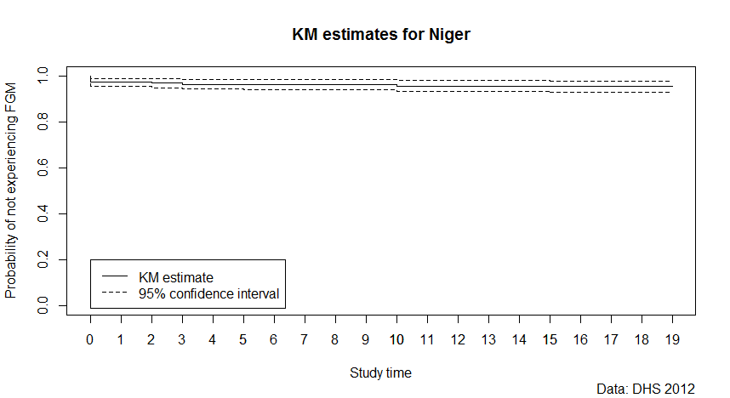

|  |  |  |  |
| --- | --- | --- | --- |
| Study time | Point estimate | Confidence interval (lower) | Confidence interval (upper) |
| 0 | 0.972924 | 0.95581 | 0.990042 |
| 1 | 0.972924 | 0.95581 | 0.990042 |
| 2 | 0.968751 | 0.94966 | 0.987837 |
| 3 | 0.964697 | 0.94438 | 0.985014 |
| 4 | 0.964697 | 0.94438 | 0.985014 |
| 5 | 0.962959 | 0.94137 | 0.98455 |
| 6 | 0.962959 | 0.94137 | 0.98455 |
| 7 | 0.962959 | 0.94137 | 0.98455 |
| 8 | 0.962959 | 0.94137 | 0.98455 |
| 9 | 0.962959 | 0.94137 | 0.98455 |
| 10 | 0.957032 | 0.93289 | 0.981177 |
| 11 | 0.957032 | 0.93289 | 0.981177 |
| 12 | 0.957032 | 0.93289 | 0.981177 |
| 13 | 0.957032 | 0.93289 | 0.981177 |
| 14 | 0.957032 | 0.93289 | 0.981177 |
| 15 | 0.955166 | 0.9308 | 0.979538 |
| 16 | 0.955166 | 0.9308 | 0.979538 |
| 17 | 0.955166 | 0.9308 | 0.979538 |
| 18 | 0.955166 | 0.9308 | 0.979538 |
| 19 | 0.955166 | 0.930795 | 0.979538 |

**Figure 20: Kaplan Meier Survival Curve for FGM in Nigeria**

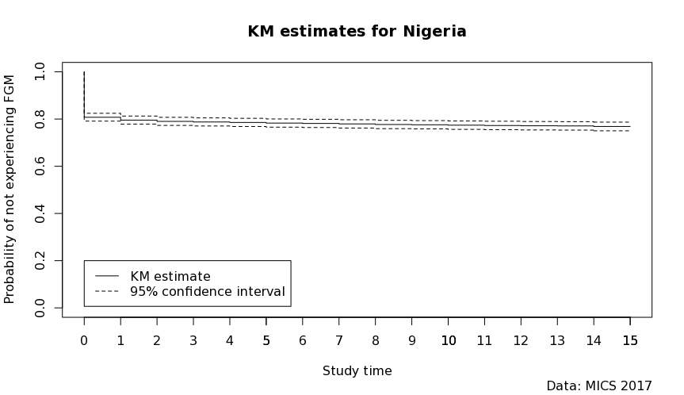

|  |  |  |  |
| --- | --- | --- | --- |
| Study time | Point estimate | Confidence interval (lower) | Confidence interval (upper) |
| 0 | 0.80779 | 0.791155 | 0.824417 |
| 1 | 0.79579 | 0.778776 | 0.8128 |
| 2 | 0.79027 | 0.773116 | 0.807417 |
| 3 | 0.78782 | 0.770606 | 0.805026 |
| 4 | 0.78577 | 0.768494 | 0.803055 |
| 5 | 0.78318 | 0.765814 | 0.800555 |
| 6 | 0.78161 | 0.764139 | 0.799084 |
| 7 | 0.77952 | 0.761949 | 0.797095 |
| 8 | 0.77706 | 0.75947 | 0.794657 |
| 9 | 0.77594 | 0.758299 | 0.79358 |
| 10 | 0.77413 | 0.756346 | 0.79191 |
| 11 | 0.77293 | 0.755106 | 0.790762 |
| 12 | 0.77175 | 0.753853 | 0.789646 |
| 13 | 0.77112 | 0.753118 | 0.789129 |
| 14 | 0.7686 | 0.750166 | 0.787038 |
| 15 | 0.7686 | 0.750166 | 0.787038 |

**Figure 21: Kaplan Meier Survival Curve for FGM in Senegal**

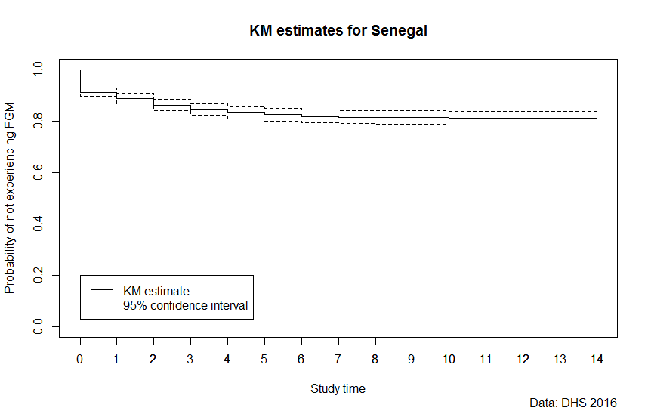

|  |  |  |  |
| --- | --- | --- | --- |
| Study time | Point estimate | Confidence interval (lower) | Confidence interval (upper) |
| 0 | 0.91262 | 0.896308 | 0.928926 |
| 1 | 0.88773 | 0.868339 | 0.90713 |
| 2 | 0.86189 | 0.839798 | 0.883973 |
| 3 | 0.84612 | 0.822971 | 0.869262 |
| 4 | 0.83394 | 0.809213 | 0.858671 |
| 5 | 0.82545 | 0.80042 | 0.850479 |
| 6 | 0.8184 | 0.792799 | 0.843998 |
| 7 | 0.81544 | 0.789554 | 0.841319 |
| 8 | 0.81417 | 0.788233 | 0.840102 |
| 9 | 0.81362 | 0.787603 | 0.839639 |
| 10 | 0.81048 | 0.784608 | 0.836349 |
| 11 | 0.81048 | 0.784608 | 0.836349 |
| 12 | 0.81048 | 0.784608 | 0.836349 |
| 13 | 0.81048 | 0.784608 | 0.836349 |
| 14 | 0.81048 | 0.784608 | 0.836349 |

**Figure 22: Kaplan Meier Survival Curve for FGM in Sierra Leone**

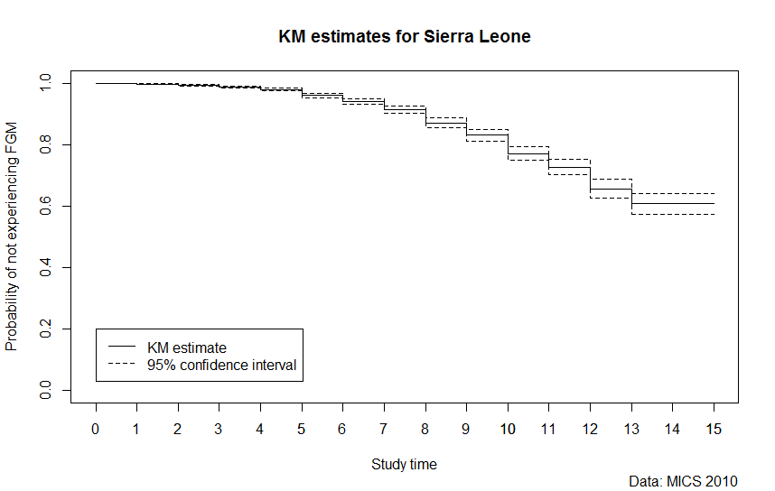

|  |  |  |  |
| --- | --- | --- | --- |
| Study time | Point estimate | Confidence interval (lower) | Confidence interval (upper) |
| 0 | 0.999047 | 0.998389 | 0.999705 |
| 1 | 0.997511 | 0.996325 | 0.998697 |
| 2 | 0.994063 | 0.992072 | 0.996053 |
| 3 | 0.988303 | 0.985143 | 0.991463 |
| 4 | 0.980145 | 0.975809 | 0.984481 |
| 5 | 0.96036 | 0.953049 | 0.967671 |
| 6 | 0.940569 | 0.93086 | 0.950278 |
| 7 | 0.913697 | 0.902407 | 0.924987 |
| 8 | 0.871491 | 0.856298 | 0.886684 |
| 9 | 0.83158 | 0.812716 | 0.850443 |
| 10 | 0.771718 | 0.748346 | 0.795091 |
| 11 | 0.726444 | 0.701555 | 0.751334 |
| 12 | 0.657338 | 0.627229 | 0.687447 |
| 13 | 0.607134 | 0.573601 | 0.640667 |
| 14 | 0.607134 | 0.573601 | 0.640667 |
| 15 | 0.607134 | 0.573601 | 0.640667 |

**Figure 23: Kaplan Meier Survival Curve for FGM in (a) Somaliland and (b) Somalia North East Zone**

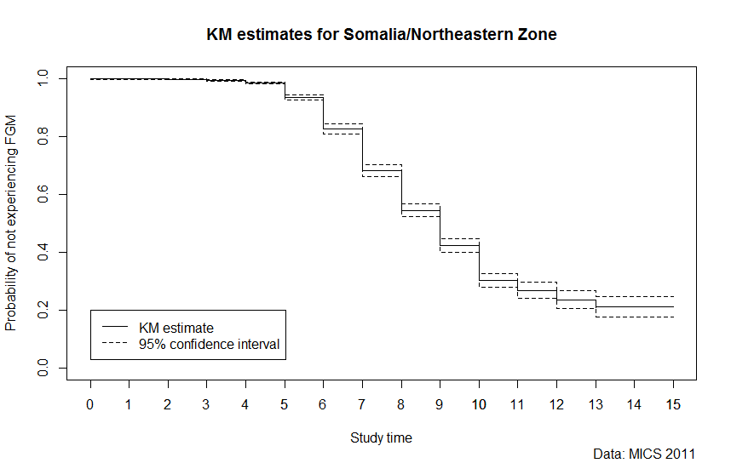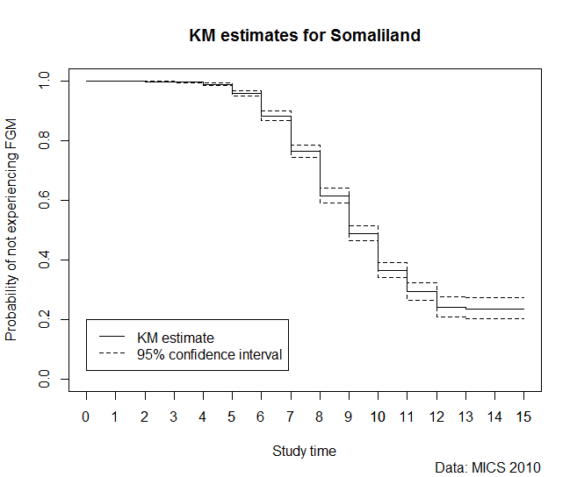

|  |  |  |  |  |  |  |  |  |  |
| --- | --- | --- | --- | --- | --- | --- | --- | --- | --- |
| Study time | Point estimate | | Confidence interval (lower) | Confidence interval (upper) | Study time | Point estimate | | Confidence interval (lower) | Confidence interval (upper) |
| 0 | 0.998909 | 0.997818 | | 1 | 0 | 1 | 1 | | 1 |
| 1 | 0.998249 | 0.996566 | | 0.999933 | 1 | 0.999178 | 0.998356 | | 1 |
| 2 | 0.99745 | 0.995467 | | 0.999434 | 2 | 0.998014 | 0.996697 | | 0.999331 |
| 3 | 0.994574 | 0.991872 | | 0.997276 | 3 | 0.996007 | 0.994004 | | 0.998009 |
| 4 | 0.984811 | 0.980469 | | 0.989153 | 4 | 0.988812 | 0.984663 | | 0.992961 |
| 5 | 0.934598 | 0.92467 | | 0.944527 | 5 | 0.957637 | 0.948566 | | 0.966708 |
| 6 | 0.825922 | 0.809357 | | 0.842487 | 6 | 0.882054 | 0.866022 | | 0.898085 |
| 7 | 0.682769 | 0.662531 | | 0.703007 | 7 | 0.763941 | 0.74234 | | 0.785543 |
| 8 | 0.544329 | 0.522326 | | 0.566332 | 8 | 0.615509 | 0.591198 | | 0.63982 |
| 9 | 0.424 | 0.400002 | | 0.447998 | 9 | 0.489007 | 0.46352 | | 0.514495 |
| 10 | 0.302915 | 0.278431 | | 0.3274 | 10 | 0.366375 | 0.340796 | | 0.391955 |
| 11 | 0.267674 | 0.239539 | | 0.295809 | 11 | 0.29395 | 0.265429 | | 0.322472 |
| 12 | 0.237415 | 0.206898 | | 0.267932 | 12 | 0.243088 | 0.208668 | | 0.277507 |
| 13 | 0.212314 | 0.176316 | | 0.248313 | 13 | 0.238017 | 0.201586 | | 0.274449 |
| 14 | 0.212314 | 0.176316 | | 0.248313 | 14 | 0.238017 | 0.201586 | | 0.274449 |
| 15 | 0.212314 | 0.176316 | | 0.248313 | 15 | 0.238017 | 0.201586 | | 0.274449 |

## **Figure 24: Kaplan Meier Survival Curve for FGM in Sudan**

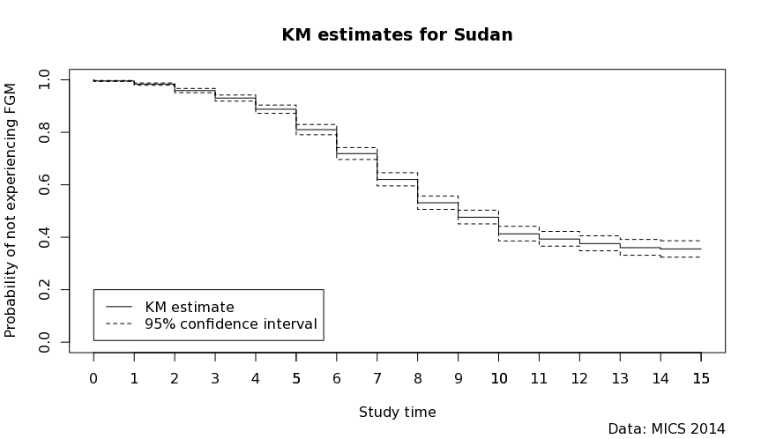

|  |  |  |  |
| --- | --- | --- | --- |
| Study time | Point estimate | Confidence interval (lower) | Confidence interval (upper) |
| 0 | 0.995832 | 0.993973 | 0.99769 |
| 1 | 0.983911 | 0.979556 | 0.988267 |
| 2 | 0.959167 | 0.95093 | 0.967404 |
| 3 | 0.93059 | 0.918898 | 0.942282 |
| 4 | 0.888217 | 0.872468 | 0.903966 |
| 5 | 0.810384 | 0.790903 | 0.829864 |
| 6 | 0.719174 | 0.69652 | 0.741828 |
| 7 | 0.620882 | 0.595671 | 0.646092 |
| 8 | 0.531875 | 0.506286 | 0.557463 |
| 9 | 0.476962 | 0.45089 | 0.503033 |
| 10 | 0.41375 | 0.385858 | 0.441642 |
| 11 | 0.394146 | 0.366011 | 0.422282 |
| 12 | 0.376945 | 0.348389 | 0.4055 |
| 13 | 0.361381 | 0.331198 | 0.391563 |
| 14 | 0.355413 | 0.324103 | 0.386722 |
| 15 | 0.355413 | 0.324103 | 0.386722 |

**Figure 25: Kaplan Meier Survival Curve for FGM in Tanzania**

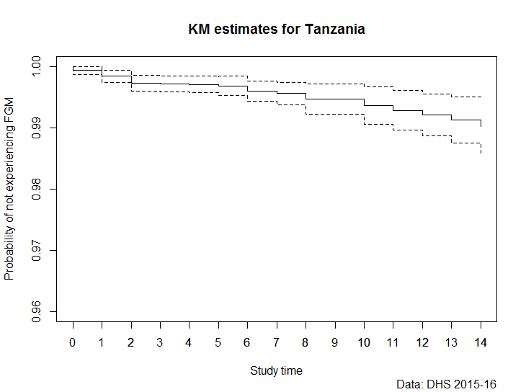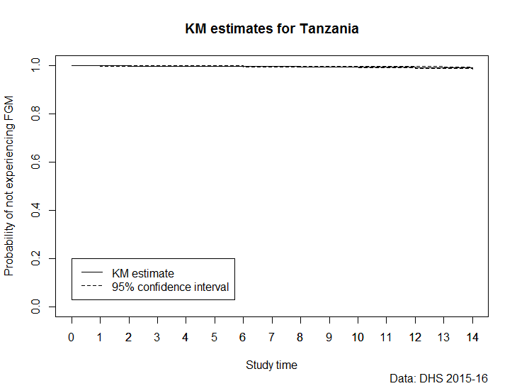

|  |  |  |  |
| --- | --- | --- | --- |
| Study time | Point estimate | Confidence interval (lower) | Confidence interval (upper) |
| 0 | 0.99935 | 0.998696 | 1 |
| 1 | 0.9984 | 0.997449 | 0.999353 |
| 2 | 0.99727 | 0.995969 | 0.998567 |
| 3 | 0.99717 | 0.995875 | 0.998473 |
| 4 | 0.99706 | 0.995712 | 0.998416 |
| 5 | 0.99682 | 0.995245 | 0.998392 |
| 6 | 0.99599 | 0.994334 | 0.997655 |
| 7 | 0.99558 | 0.993783 | 0.997367 |
| 8 | 0.99469 | 0.992178 | 0.997195 |
| 9 | 0.99469 | 0.992178 | 0.997195 |
| 10 | 0.9936 | 0.990547 | 0.996663 |
| 11 | 0.99283 | 0.989587 | 0.996065 |
| 12 | 0.9921 | 0.98865 | 0.995555 |
| 13 | 0.9913 | 0.987536 | 0.99507 |
| 14 | 0.99022 | 0.985909 | 0.99453 |

**Figure 26: Kaplan Meier Survival Curve for FGM in Togo**

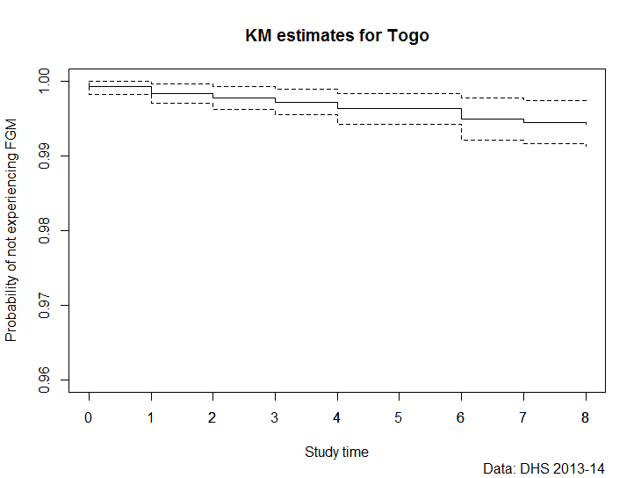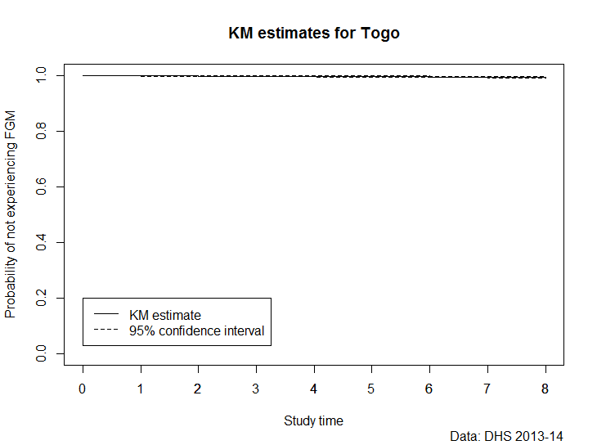

|  |  |  |  |
| --- | --- | --- | --- |
| Study time | Point estimate | Confidence interval (lower) | Confidence interval (upper) |
| 0 | 0.99912 | 0.998246 | 1 |
| 1 | 0.99832 | 0.997022 | 0.999615 |
| 2 | 0.99772 | 0.996209 | 0.99924 |
| 3 | 0.99721 | 0.995462 | 0.998964 |
| 4 | 0.99629 | 0.99423 | 0.998344 |
| 5 | 0.99629 | 0.99423 | 0.998344 |
| 6 | 0.99494 | 0.992155 | 0.997723 |
| 7 | 0.9945 | 0.991614 | 0.997388 |
| 8 | 0.9942 | 0.991279 | 0.997125 |
| 9 | 0.9942 | 0.991279 | 0.997125 |
| 10 | 0.9942 | 0.991279 | 0.997125 |
| 11 | 0.9942 | 0.991279 | 0.997125 |
| 12 | 0.9942 | 0.991279 | 0.997125 |
| 13 | 0.9942 | 0.991279 | 0.997125 |
| 14 | 0.9942 | 0.991279 | 0.997125 |

**Figure 27: Kaplan Meier Survival Curve for FGM in Yemen**

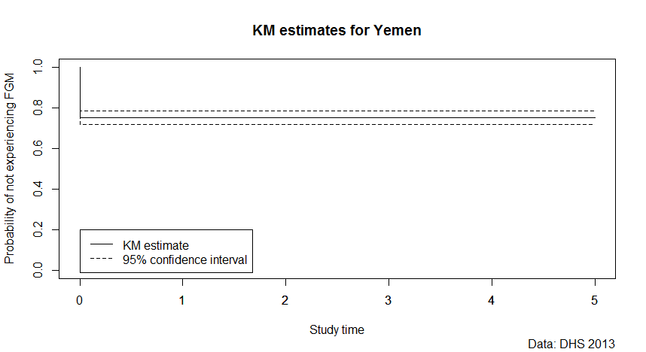

|  |  |  |  |  |  |
| --- | --- | --- | --- | --- | --- |
| Study time | Point estimate | Confidence interval (lower) | | Confidence interval (upper) | |
| 0 | 0.752241 | | 0.71953 | | 0.784954 |
| 1 | 0.752241 | | 0.71953 | | 0.784954 |
| 2 | 0.751837 | | 0.71911 | | 0.784563 |
| 3 | 0.751837 | | 0.71911 | | 0.784563 |
| 4 | 0.751837 | | 0.71911 | | 0.784563 |
| 5 | 0.751609 | | 0.71888 | | 0.784343 |
| 6 | 0.751609 | | 0.71888 | | 0.784343 |
| 7 | 0.751609 | | 0.71888 | | 0.784343 |
| 8 | 0.751609 | | 0.71888 | | 0.784343 |
| 9 | 0.751609 | | 0.71888 | | 0.784343 |
| 10 | 0.751609 | | 0.71888 | | 0.784343 |
| 11 | 0.751609 | | 0.71888 | | 0.784343 |
| 12 | 0.751609 | | 0.71888 | | 0.784343 |
| 13 | 0.751609 | | 0.71888 | | 0.784343 |
| 14 | 0.751609 | | 0.718876 | | 0.784343 |
| 15 | 0.751609 | | 0.718876 | | 0.784343 |
| 16 | 0.751609 | | 0.718876 | | 0.784343 |
| 17 | 0.751609 | | 0.718876 | | 0.784343 |
| 18 | 0.751609 | | 0.718876 | | 0.784343 |
| 19 | 0.751609 | | 0.718876 | | 0.784343 |

## **Annex III**

Description of Estimation Method used for available RISKESDAS Indonesia Survey data on FGM

The microdata from the 2013 RISKESDAS survey in Indonesia were not available. The DHS and MICS surveys usually collect information about the FGM incidence of girls and women between ages 0 and 14 years, however the 2013 RISKDESDAS survey in Indonesia only reports FGM incidence for girls age 0 to 11 years. We therefore used a summary tabulation of the survey data that reported the incidence of cutting disaggregated by the following summary age groups: 0 months, 1-5 months, 6-11 months, 1-4 years, and 5-11 years. In order to be conservative with the limited data on Indonesia to which we currently have access, we only included the risk of girls to be cut in the first year of their life in the final estimates.

## **Annex IV**

## DHS questionnaire module

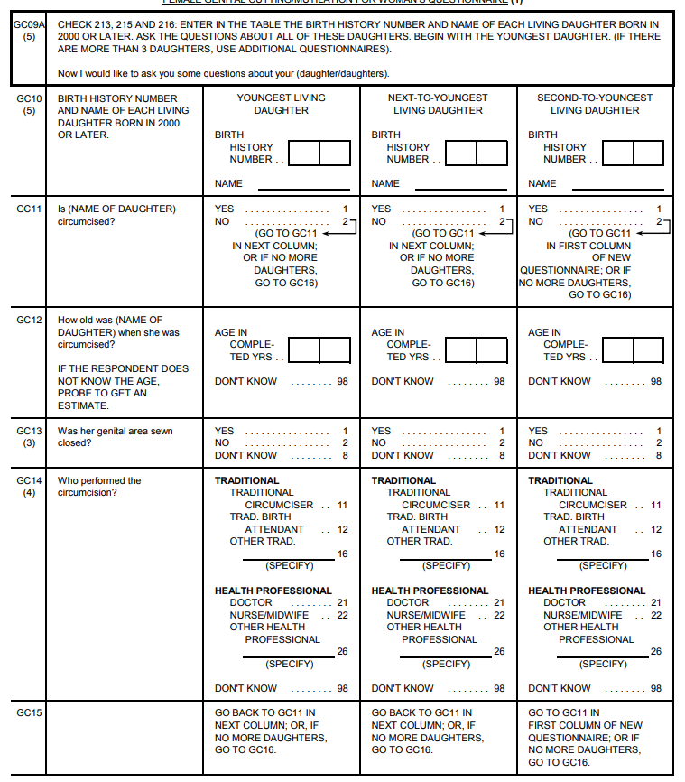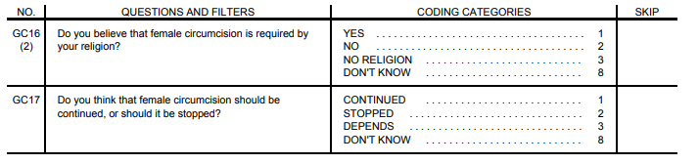

## Source: The Demographic and Health Survey (DHS) Program 2016

**MICS questionnaire, FGM module**

|  |  |  |
| --- | --- | --- |
| **FEMALE GENITAL MUTILATION/CUTTING** | | **FG** |
| **FG1. Have you ever heard of female circumcision?** | **Yes..................................................................................... 1**  **No....................................................................................... 2** | **1*ðFG3*** |
| **FG2. In some countries, there is a practice in which a girl may have part of her genitals cut.**    **Have you ever heard about this practice?** | **Yes..................................................................................... 1**  **No....................................................................................... 2** | **2*ðEnd*** |
| **FG3. Have you yourself ever been circumcised?** | **Yes..................................................................................... 1**  **No....................................................................................... 2** | **2*ðFG9*** |
| **FG4. Now I would like to ask you what was done to you at that time.**    **Was any flesh removed from the genital area?** | **Yes..................................................................................... 1**  **No....................................................................................... 2**    **DK....................................................................................... 8** | **1*ðFG6*** |
| **FG5. Was the genital area just nicked without removing any flesh?** | **Yes..................................................................................... 1**  **No....................................................................................... 2**    **DK....................................................................................... 8** |  |
| **FG6. Was the genital area sewn closed?**    **If necessary, probe: Was it sealed?** | **Yes..................................................................................... 1**  **No....................................................................................... 2**    **DK....................................................................................... 8** |  |
| **FG7. How old were you when you were circumcised?**    ***If the respondent does not know the exact age, probe to get an estimate.*** | **Age at circumcision.................................... __ __**    **DK / Don’t remember.......................................... 98** |  |
| **FG8. Who performed the circumcision?** | **Health professional**  **.. Doctor...................................................................... 11**  **.. Nurse/Midwife .................................................... 12**  **Other health professional**  **(specify)______________________________ 16**    **Traditional persons**  **.. Traditional ‘circumciser’........................ 21**  **.. Traditional birth attendant................. 22**  **_ Other traditional**  **(specify)______________________________ 26**    **DK..................................................................................... 98** |  |
| **FG9*.* *Sum CM4 for Number of daughters at home and CM7 for Number of daughters elsewhere:*** | **Total number of living**  **.. daughters*................................................... ___ ___*** |  |
| **FG10. Just to make sure that I have this right, you have (total number in FG9) living daughters. Is this correct?** | **Yes..................................................................................... 1**  **No....................................................................................... 2** | **1ðFG12** |
| **FG11. Check responses to CM1-CM11 and make corrections as necessary until response in FG10 is ‘Yes’.** |  |  |
| **FG12*.* *Check FG9: Number of living daughters?*** | **No living daughters............................................ 0**  **At least one living daughter....................... 1** | **0ðFG24** |

|  |
| --- |
| **FG13. *Ask the respondent to tell you the name(s) of her daughter(s), beginning with the youngest daughter (if more than one daughter). Write down the name of each daughter in FG14. Then, ask questions FG15 to FG22 for each daughter at a time.***    ***The total number of daughters in FG14 should be equal to the number in FG9.***    ***If more than 4 daughters, use additional questionnaires.*** |

|  |  |  |  |  |
| --- | --- | --- | --- | --- |
|  | **[D1]**  **Youngest** | **[D2]**  **2nd youngest** | **[D3]**  **3rd Youngest** | **[D4]**  **4th Youngest** |
| **FG14. *Name of daughter*** | **___________** | **___________** | **___________** | **___________** |
| **FG15. How old is (*name)*?** | **Age.......... ___ ___** | **Age.......... ___ ___** | **Age.......... ___ ___** | **Age.......... ___ ___** |
| **FG16. *Is (name) younger than 15 years of age?*** | **Yes.................. 1**  **No.................... 2 *ø***  ***FG23*** | **Yes.................. 1**  **No.................... 2 *ø***  ***FG23*** | **Yes.................. 1**  **No.................... 2 *ø***  ***FG23*** | **Yes.................. 1**  **No.................... 2 *ø***  ***FG23*** |
| **FG17. Is (*name*) circumcised?** | **Yes.................. 1**  **No.................... 2 *ø***  ***FG23*** | **Yes.................. 1**  **No.................... 2 *ø***  ***FG23*** | **Yes.................. 1**  **No.................... 2 *ø***  ***FG23*** | **Yes.................. 1**  **No.................... 2 *ø***  ***FG23*** |
| **FG18. How old was (name) when this occurred?**    ***If the respondent does not know the age, probe to get an estimate.*** | **Age......... ___ ___**    **DK...................... 98** | **Age......... ___ ___**    **DK...................... 98** | **Age......... ___ ___**    **DK...................... 98** | **Age......... ___ ___**    **DK...................... 98** |
| **FG19. Now I would like to ask you what was done to (name) at that time.**    **Was any flesh removed from the genital area?** | **Yes.................. 1 *ø***  ***FG21***    **No.................... 2**  **DK.................... 8** | **Yes................... 1 *ø***  ***FG21***    **No..................... 2**  **DK..................... 8** | **Yes.................. 1. *ø***  ***FG21***    **No.................... 2**  **DK.................... 8** | **Yes.................. 1. *ø***  ***FG21***    **No.................... 2**  **DK.................... 8** |
| **FG20. Was her genital area just nicked without removing any flesh?** | **Yes...................... 1**  **No........................ 2**  **DK........................ 8** | **Yes...................... 1**  **No........................ 2**  **DK........................ 8** | **Yes...................... 1**  **No........................ 2**  **DK........................ 8** | **Yes...................... 1**  **No........................ 2**  **DK........................ 8** |
| **FG21. Was her genital area sewn closed?**    **If necessary, probe: Was it sealed?** | **Yes...................... 1**  **No........................ 2**  **DK........................ 8** | **Yes...................... 1**  **No........................ 2**  **DK........................ 8** | **Yes...................... 1**  **No........................ 2**  **DK........................ 8** | **Yes...................... 1**  **No........................ 2**  **DK........................ 8** |
| **FG22. Who performed the circumcision?** | **Health professional**  **Doctor............. 11**  **Nurse/midwife 12**  **Other health**  **professional**  **(***specify*)_______ 16    **Traditional persons**  **Traditional**  **‘circumciser’ 21**  **Traditional**  **birth**  **attendant.... 22**  **Other ................... traditional**  **(*specify*)_______ 26**    **DK........................ 98** | **Health professional**  **Doctor............. 11**  **Nurse/midwife 12**  **Other health**  **professional**  **(***specify*)_______ 16    **Traditional persons**  **Traditional**  **‘circumciser’ 21**  **Traditional**  **birth**  **attendant.... 22**  **Other ................... traditional**  **(*specify*)_______ 26**    **DK............................ 98** | **Health professional**  **Doctor............. 11**  **Nurse/midwife 12**  **Other health**  **professional**  **(***specify*)_______ 16    **Traditional persons**  **Traditional**  **‘circumciser’ 21**  **Traditional**  **birth**  **attendant.... 22**  **Other ................... traditional**  **(*specify*)_______ 26**    **DK........................ 98** | **Health professional**  **Doctor............. 11**  **Nurse/midwife 12**  **Other health**  **professional**  **(***specify*)_______ 16    **Traditional persons**  **Traditional**  **‘circumciser’ 21**  **Traditional**  **birth**  **attendant.... 22**  **Other ................... traditional**  **(*specify*)_______ 26**    **DK........................ 98** |
| **FG23. *Is there another daughter?*** | **Yes.................. 1 *ø***  ***[D2]***  **No.................... 2 *ø***  ***FG24*** | **Yes.................. 1 *ø***  ***[D3]***  **No.................... 2 *ø***  ***FG24*** | **Yes.................. 1 *ø***  ***[D4]***  **No.................... 2 *ø***  ***FG24*** | **Yes.................. 1 *ø***  ***[D5]***  **No.................... 2 *ø***  ***FG24*** |
|  |  |  |  | ***Tick here if additional questionnaire***  ***used:....................* ¨** |

|  |  |  |
| --- | --- | --- |
| **FG24. Do you think this practice should be continued or should it be discontinued?** | **Continued.................................................................... 1**  **Discontinued............................................................. 2**  **Depends.......................................................................... 3**  **DK....................................................................................... 8** |  |

Source: UNICEF, 2017

1. ¥ Population and Development Branch
2.
3. ϒ Gender, Human Rights and Gender Branch
4.
5.
6. *Acknowledgements: We would like to thank Professor Ngianga-Bakwin Kandala, Northumbria University for his inputs and guidance at the beginning of the analytical stages, Patrick Gerland, Population Division, UN DESA, for crucial input and comments.* 
7. Data are only included for countries that have nationally-representative survey data on FGM in the last 10 years. As the most recent data on FGM for Cameroon, Djibouti, and Eritrea are prior to 2010, these countries are not included in this analysis. Uganda and Liberia had to be excluded from the analysis as the precise age of cutting was not recorded in the surveys. For a full listing, please refer to table 1 in Annex I.
8. A detailed analysis of the Indonesian RISKESDAS data was not possible, given that these microdata are not publicly accessible. Therefore, we utilized a summary tabulation of the FGM data from the RISKESDAS survey. See Annex III for more information.
9. see DHS 2016 and Annex IV.1 for complete questionnaire.
10. see UNICEF 2017 and Annex IV.2 for complete questionnaire.
11. Population Division, Department of Economic and Social Affairs of the United Nations, available at: <https://esa.un.org/unpd/wpp/>
12. The medium variant of single-year age population projections from the 2017 revision of the World Population Prospections is used.
13. There have been some studies on FGM amongst migrants in France, Germany and USA (Johnsdotter and Essen 2015; Goldberg et al 2015, Leye et al 2014, MAcfarlane and Dorkenoo 2014, Ortesni et al 2014).
14. The specific estimation method used for the available Indonesia RISKESDAS data are documented in Annex III.